

**DHIRUBHAI AMBANI INSTITUTE OF INFORMATION AND COMMUNICATION TECHNOLOGY**

**Master of Science in Information &Technology**

**Project: AlmaPlus**

202312120 - Pratham Trivedi

202312104 - Rudra Bhatt  
202312035 - Swati Gamit  
202312001 - Tulsi Rathod

Course: Software Engineering

**INDEX**

|  |  |  |
| --- | --- | --- |
| **No.** | **Particulars** | **Page** |
| 1. | Project Proﬁle | 3 |
| 2. | Introduction   * 1. Scope   2. Objective   3. Existing System   4. Purpose of System   5. Advantages   6. Feasibility Study | 4 |
| 3. | System Environment  3.1 Hardware & Software Requirement Speciﬁcation | 8 |
| 4. | System Analysis and Modeling   * 1. Entity Relationship Diagram   2. Data Flow Diagram   3. Data Dictionary   4. Use Case Diagram   5. Class Diagram   6. Activity Diagram   7. Sequence Diagram | 11 |
| 5. | Testing | 27 |
| 6. | Design   * 1. Database design   2. Interface design | 28 |
| 7. | Reference | 34 |

1. **PROJECT PROFILE**

|  |  |
| --- | --- |
| **Project Title** | AlmaPlus |
| **Project Definition** | AlmaPlus WebApplication is used to connect College students with their Alumni and can communicate with them. |
| **Frontend** | ReactJS (Javascript) |
| **Backend** | NodeJS |
| **Database** | MongoDB (NoSql) |
| **Project Category** | Web Application (PWA) |
| **Documentation Tool** | Ms-Office |
| **Editor** | Visual Studio |
| **Developed By** | Pratham Trivedi  Rudra Bhatt  Swati Gamit  Tulsi Rathod |

1. **INTRODUCTION**
   * AlmaPlus is a web application that allows college management to store the details of both current and former students of the college.
   * It also enables communication between them, with new students being able to seek information on job vacancies, career advice, and subject details from alumni.
   * Manually collecting and storing student data through pen and paper methods can be a tedious task, and offers no security for the stored data.
   * By using the AlmaPlus website, this work can be avoided, and student details can be retrieved with just one mouse click.

## SCOPE

**Functional requirement of the project:**

The purpose of this section is to cover each and every module of the web app project. Please review this section carefully and let us know your feedback if you would like to make any changes.

**User Types (Key Stakeholders):** The web app will have the following types of users.

|  |  |  |
| --- | --- | --- |
| **User Role** | **Description** | **Platform** |
| Institute | Institutes are the clients of almaPlus, and almaPlus will organise and manage connections for their students. These users will have a separate panel from where they can log in and check all student details, | Web Based Panel |

|  |  |  |
| --- | --- | --- |
|  | manage their students/alumni, and post events. |  |
| Alumni | Alumni are users who have graduated from the respective institute. They can make connections with students and help them in their career by offering valuable suggestions, job opportunities, or internship programs. They can also share posts that can be helpful to students. | Web Based Panel |
| Students | Students are the users who are currently studying in the respected institute. They can make connections with alumni and ask for help in their career. Students can also share posts to preserve college memories for a lifetime. | Web Based Panel |
| Admin | The admin will be the product owner who will be responsible for institute onboarding, managing their students and alumni, checking various reports, and managing feedback & ratings, as well as service charges. | Web Based Panel |

* + - **Key Features of students and alumni**
* Register / Login
* Proﬁle Management
* Search Person
* Make Connection
* Make Chat
* Financial Aid
* Add Post
* View Event And join the event
* Get Notiﬁcation
* Feedback & Rating
* Logout
  + - **Key Features of Institute**
* Register / Login
* Buy Service
* Proﬁle Management
* Student Management
* Alumni Management
* Add Post
* Events Management
* Logout
* Manage Financial Aid
  + - **Key Features of Admin**
* Register / Login
* Proﬁle Management
* Institute Management
* Student Management
* Alumni Management
* Events Management
* Notiﬁcation Management
* Feedback & Rating Management
* CMS Management
* Logout

## OBJECTIVE

* The aim of this Alumni Management System project is to build a system that can manage alumni data of an institute and provide easy access to it.
* While alumni of an institute generally stay in touch with their immediate friends, they may find it hard to stay connected with other college mates.
* Contact between alumni can be used to forge business connections and to gain references or insight in a new field.
* New college students will be initially given a student login ID to access the system, which can help them in building connections for their projects or placements. Alumni will also be able to provide public posts on the system about possible job opportunities or other college-related news. As alumni are unlikely to check the system frequently, the system will be able to collate all public posts and create a newsletter that can be emailed to all alumni.
* The system will also have a chat feature that enables alumni to chat without revealing their mobile number or personal email ID.

## EXISTING SYSTEM

Many colleges still maintain records of present and former students manually. Re-collecting this data in the manual system can be difficult, and if a student needs information about former students, they have to approach college management. Overall, collecting information in this system can be a very tedious task.

* **LIMITATIONS OF EXISTING SYSTEM**
* The current system is not completely computerised and involves manual entry of students and staff data, making it difficult to handle.
* There is no centralised database maintenance, and accessing a particular student record is not easy.
* Additionally, the students cannot easily navigate through the database, which limits their ability to access relevant information.

## PROPOSED SYSTEM

The proposed system will be online and accessible to alumni anywhere and anytime, enabling quick and easy communication. Each user will be responsible for updating their own information, and will have the option to maintain their privacy. The system will not require the constant attention of a group of students for maintenance. With the system, alumni will be able to organise meetings and find job opportunities for themselves.

## ADVANTAGES

* The main advantage of the AlmaPlus is to provide better information for the users of this system easily from anywhere without facing any diﬃculty.
* This project allows students to register online.
* Each user will also have the option to maintain their privacy.
* The students can easily access old student’s data.
* Students can directly communicate with old students regarding Job, or any enquiry.
* This system provides student to easily navigate through the application for more information in a most secure manner
* And this project has many additional features

## FEASIBILITY STUDY

Feasibility study is an assessment of the practicality of a proposed project or System. Feasibility study is conducted once the problem is clearly understood.

The system has been tested for feasibility in the following points.

1. Technical Feasibility
2. Economical Feasibility
3. Operational Feasibility
4. Technical Feasibility

Our project is technically feasible because of the below mentioned feature. We have completed admin module and for feasibility study, we studied complete functionality of the admin module as described in the Software Requirement Speciﬁcation(SRS). Admin can successfully login to the system and perform tasks assigned to the admin.

1. Economical Feasibility

This is very important aspect to be considered while developing a project .We decided the technology based on the minimum possible cost factor.

1. Operational Feasibility

The proposed system is fully GUI based and it is very user friendly

# SYSTEM ENVIRONMENT

## HARDWARE & SOFTWARE REQUIREMENT

**SOFTWARE REQUIREMENT**

* + - Operating system : Windows, IoS, Linux, Android.
    - Server Side Coding Language : Node JS
    - Client Side Coding Language : React JS
    - Tool : Visual Studio
    - Database : MongoDB (NO-SQL)
    - Web Browser : Google Chrome, Safari, Firefox, IE.
    - Server : Localhost

**HARDWARE REQUIREMENT**

* + - Hard Disk : 256 GB
    - Monitor : 15’’ LED
    - Input Devices : Keyboard, Mouse
    - Ram : 2 GB.
    - Microprocessor : i3 5th gen
    - Internet Connection : 512 kbpsBroadband

# SYSTEM ANALYSIS AND MODELLING

* 1. **ER Diagram**

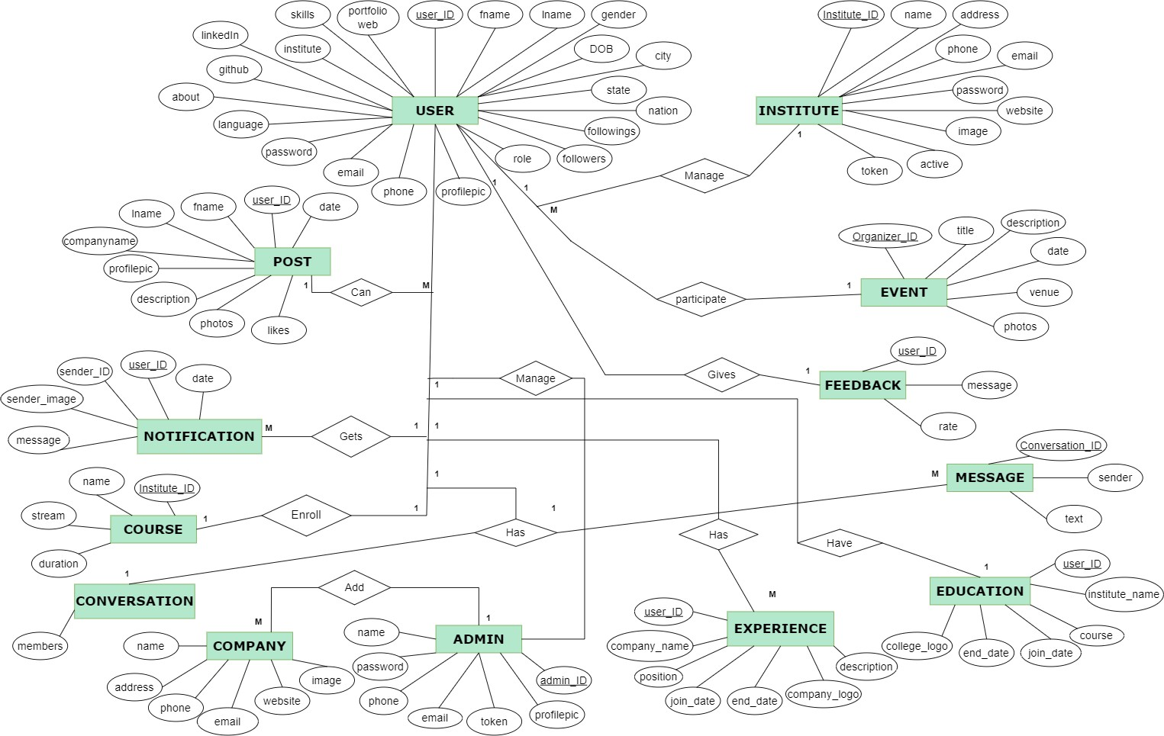

* 1. **Data Flow Diagram (DFD)**

LEVEL - 0

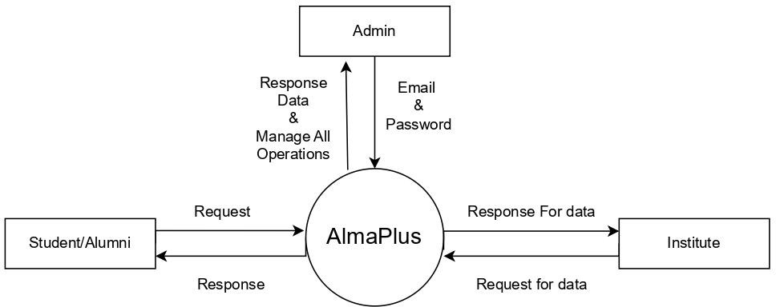

LEVEL-1 (ADMIN)

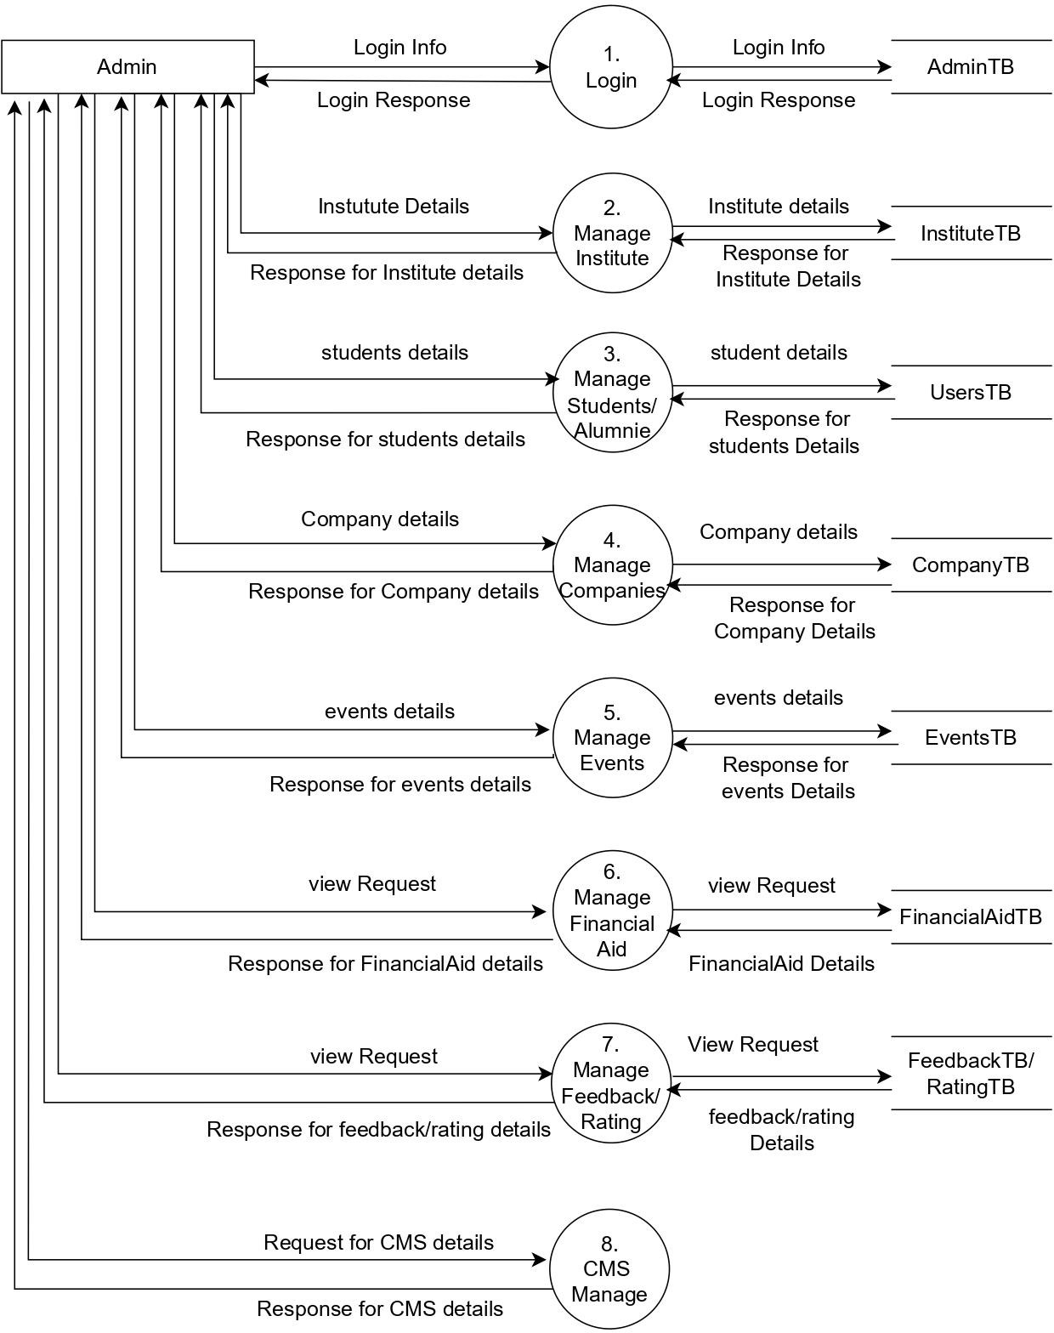

LEVEL - 1 (STUDENT/ALUMNI)

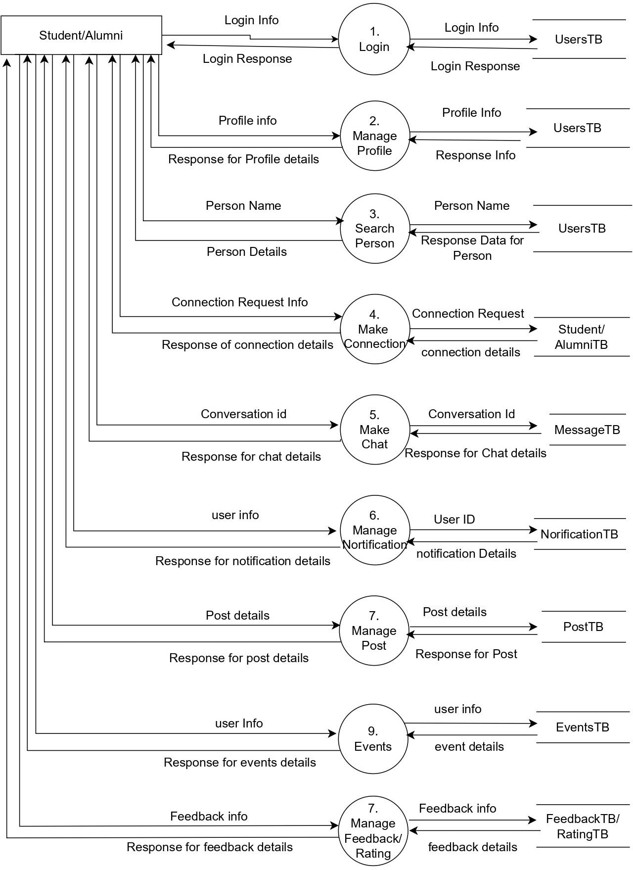

LEVEL - 1 (INSTITUTE)

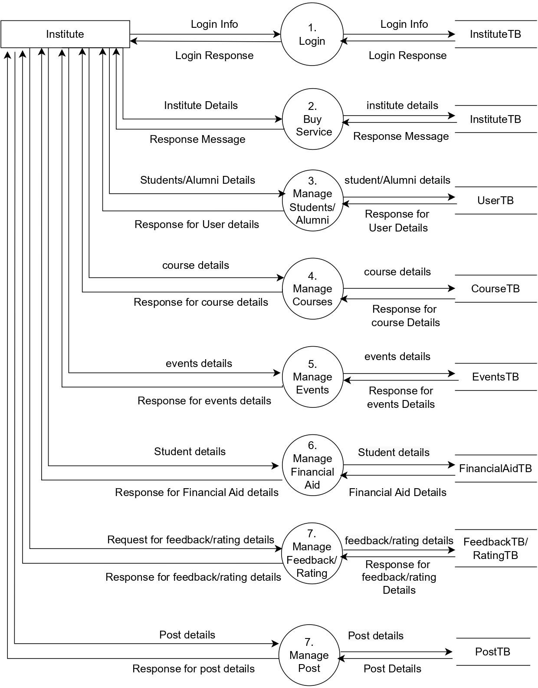

LEVEL - 2 (STUDENT/ALUMNI)

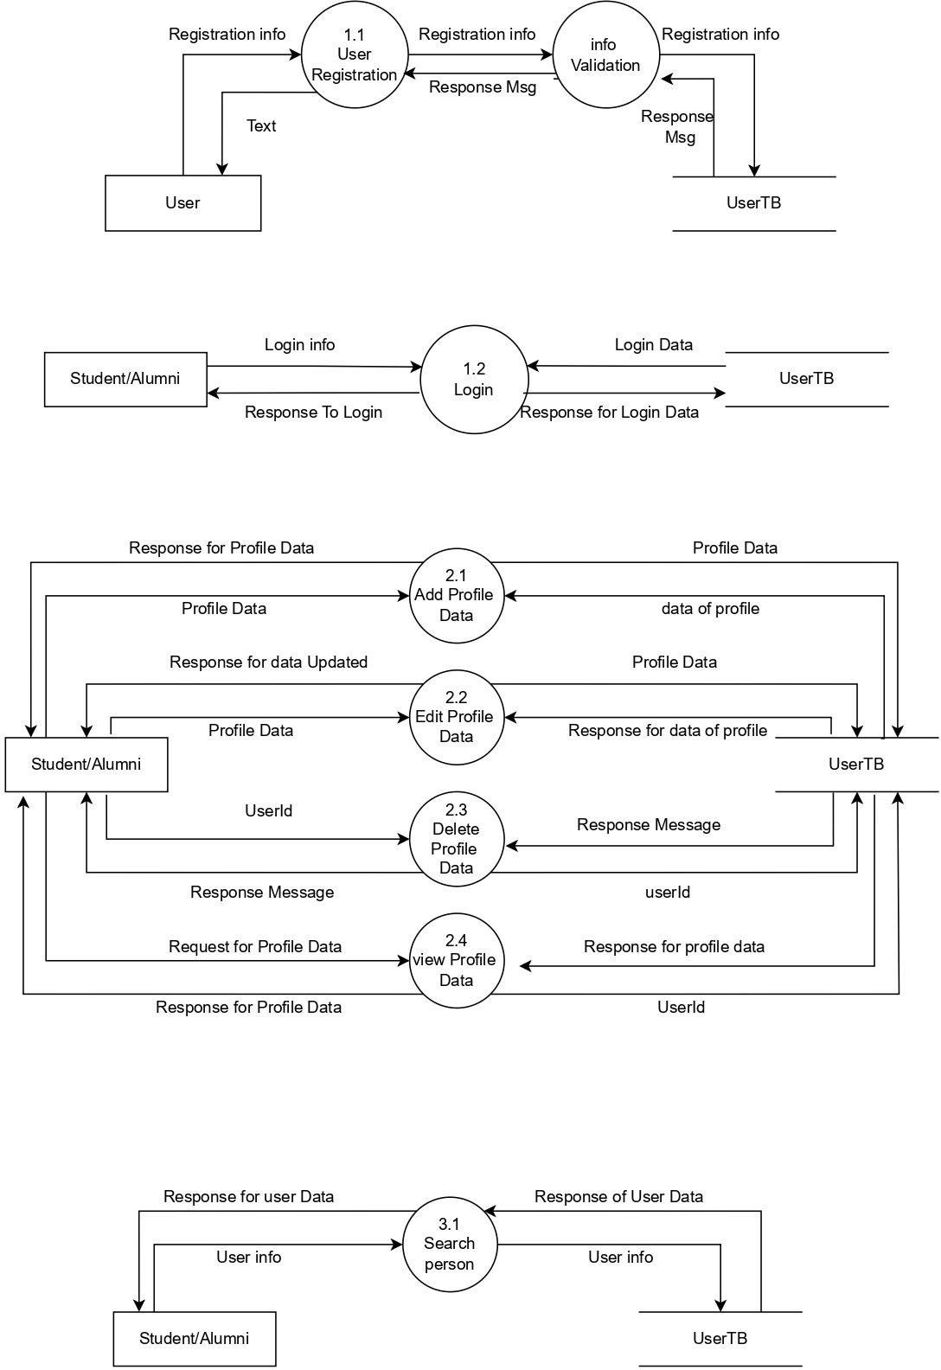

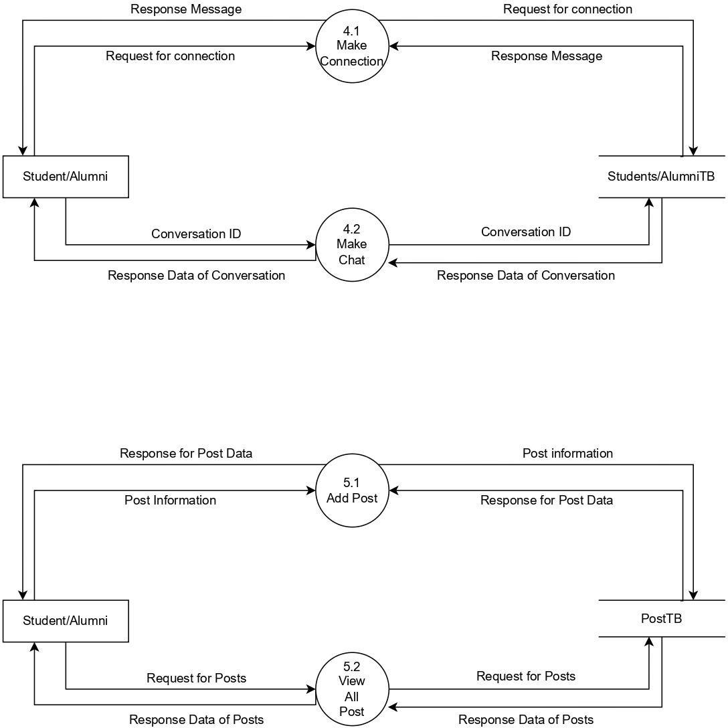

# Data Dictionary:

|  |  |
| --- | --- |
| Name | UsersTB |
| Alias | - |
| Where & How Use | User Register & Login , view Proﬁle |
| Description | userId,fname,lname,dob,password,pro ﬁlepic,address,followers,followings,ab out,institute |
| Format | Alphanumeric |

|  |  |
| --- | --- |
| Name | PostTB |
| Alias | - |
| Where & How Use | Home Page |
| Description | Userid, fname, lname, proﬁlepic, date, photos, likes |
| Format | Alphanumeric |

|  |  |
| --- | --- |
| Name | NotiﬁcationTB |
| Alias | - |
| Where & How Use | Notify User |
| Description | Userid, image, msg, date, title |
| Format | Alphanumeric |

|  |  |
| --- | --- |
| Name | MessageTB |
| Alias | - |
| Where & How Use | Chat Application |
| Description | _id, ConversationID, sender, text, time |

|  |  |
| --- | --- |
| Format | Alphanumeric |

|  |  |
| --- | --- |
| Name | InstituteTB |
| Alias | - |
| Where & How Use | Register, Login, Student Education |
| Description | Name, Address, Phone, Email, password, Website, image, active |
| Format | Alphanumeric |

|  |  |
| --- | --- |
| Name | FinancialAidTB |
| Alias | - |
| Where & How Use | Student Help Corner |
| Description | InstituteId, name, image, aid, claimed, Description, dueDate |
| Format | Alphanumeric |

|  |  |
| --- | --- |
| Name | FeedbackTB |
| Alias | - |
| Where & How Use | User Experience Feedback |
| Description | Userid, message, rating |
| Format | Alphanumeric |

|  |  |
| --- | --- |
| Name | ExperienceTB |
| Alias | - |
| Where & How Use | Show Experiences |
| Description | Userid, companyname, position, joindate, enddate, companylogo, description. |
| Format | Alphanumeric |

|  |  |
| --- | --- |
| Name | Events tbs |
| Alias | - |
| Where & How Use | Show Events |
| Description | Organizer id, title,description,date,photos,venue |
| Format | Alphanumeric |

|  |  |
| --- | --- |
| Name | Education tbs |
| Alias | - |
| Where & How Use | To show education in userproﬁle |
| Description | userid,institutename,course,joindate,e nddate,collegelogo |
| Format | Alphanumeric |

|  |  |
| --- | --- |
| Name | coursetbs |
| Alias | - |
| Where & How Use | For course data |
| Description | Instituteid,name,stream,duration |
| Format | Alphanumeric |

|  |  |
| --- | --- |
| Name | conversation tbs |
| Alias | - |
| Where & How Use | For chatting process |
| Description | id,members |
| Format | Alphanumeric |

|  |  |
| --- | --- |
| Name | companytbs |
| Alias | - |
| Where & How Use | Used for getting company data |
| Description | id,name,address,phone,email,website, image |
| Format | Alphanumeric |

|  |  |
| --- | --- |
| Name | admintb |
| Alias | - |
| Where & How Use | Used in Admin Panel |
| Description | id,name,phone,email,password,proﬁle pic |
| Format | Alpha Numeric |

* 1. **Use-case Diagram**

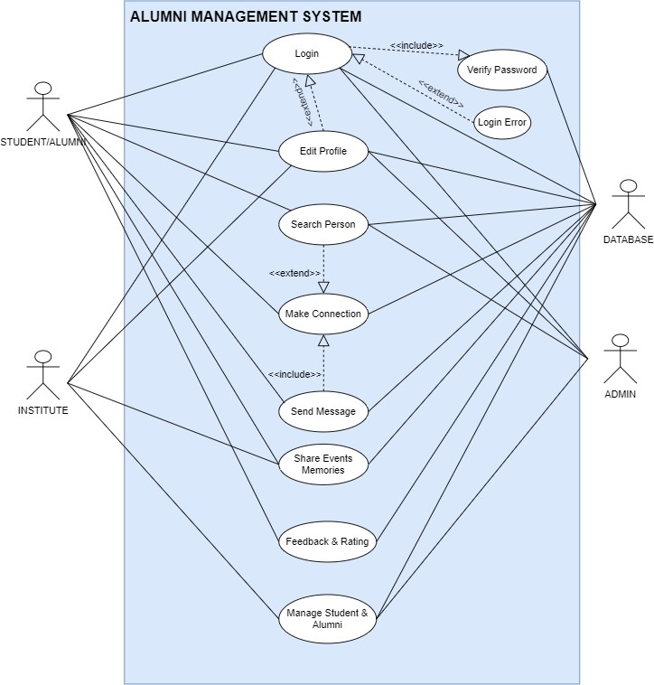

* 1. **Class Diagram**

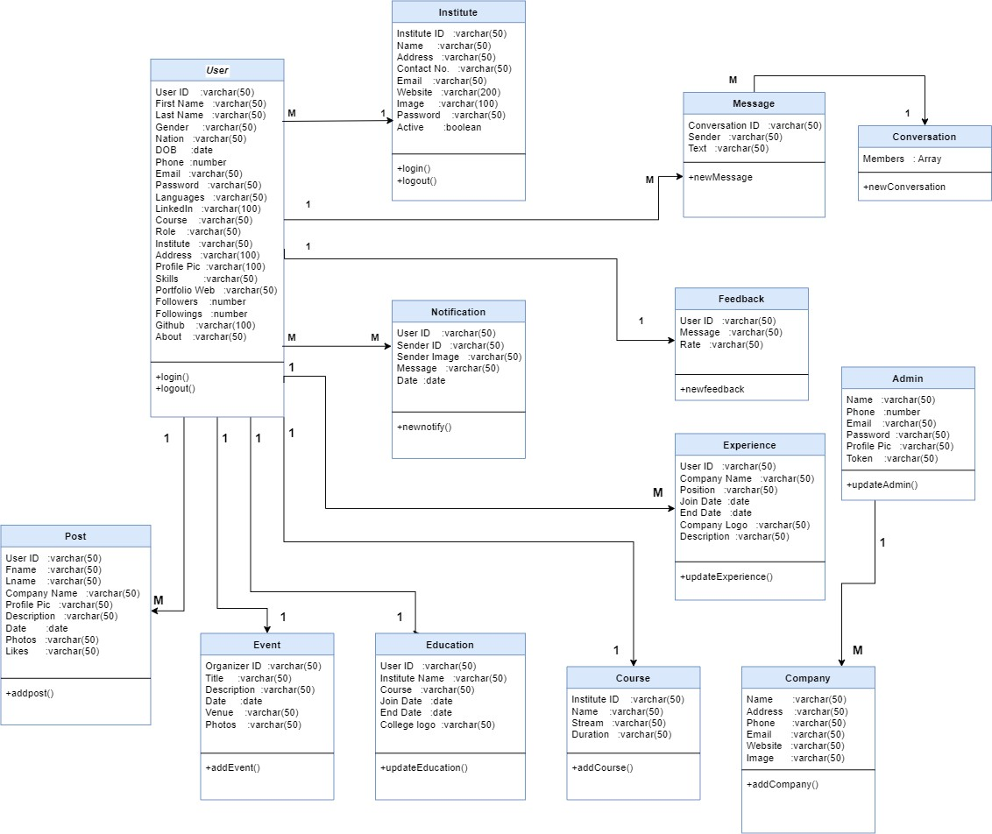

* 1. **Activity Diagram**

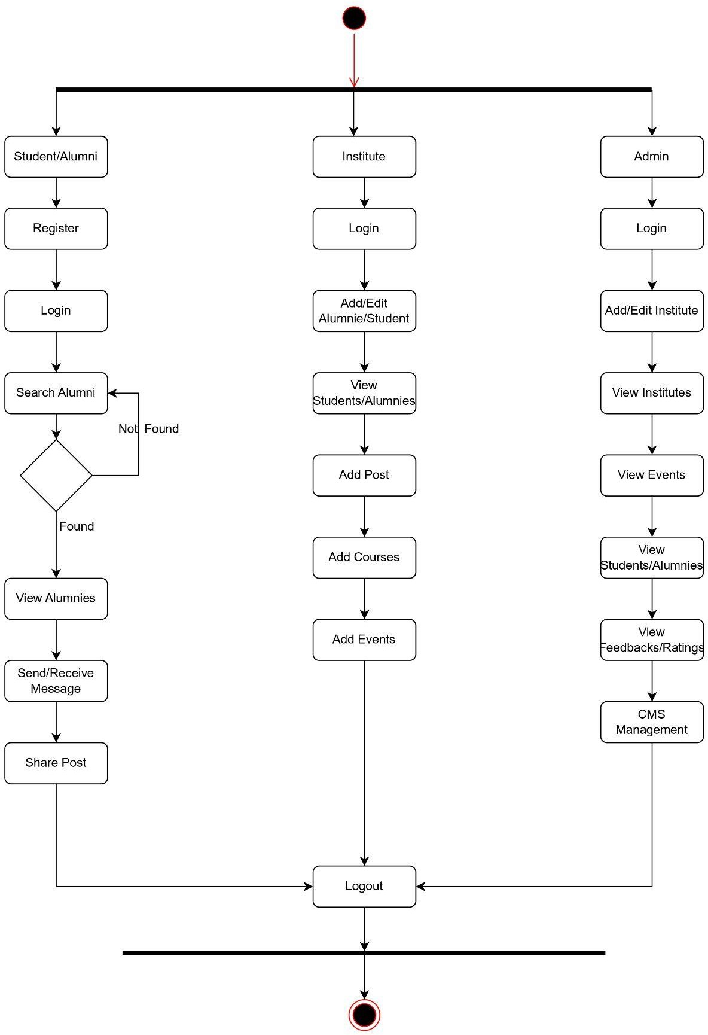

**4.8 Sequence Diagram [ Students/Alumni ]**

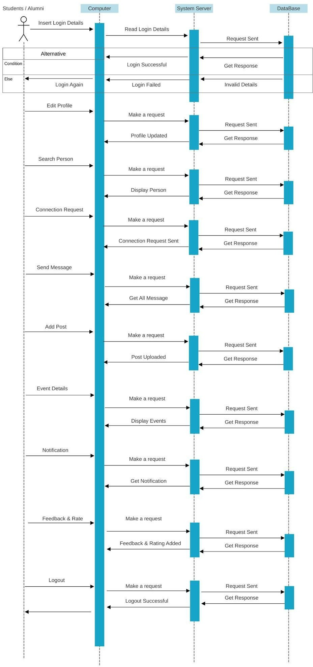

**[ Institute ]**

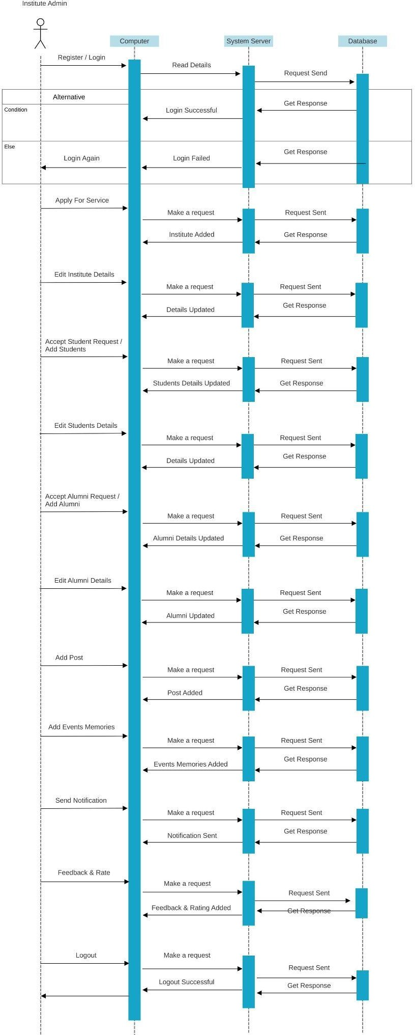

# TESTING

|  |  |
| --- | --- |
| **Test Case** | **Status** |
| **Student Login** | **True** |
| **Register** | **True** |
| **Forgot Password** | **True** |
| **Home Page** | **True** |
| **View Proﬁle** | **True** |
| **Add / Edit Proﬁle Info** | **True** |
| **Add Languages / Skills** | **True** |
| **Manage Education** | **True** |
| **Manage Experience** | **True** |
| **Manage Followers And Followings** | **True** |
| **Change Password** | **True** |
| **Search Connection** | **True** |
| **Search Connection Filter** | **True** |
| **View Connection Proﬁle** | **True** |
| **Follow / Unfollow People** | **True** |
| **Message People** | **True** |
| **Financial Aid** | **True** |
| **Notiﬁcation** | **True** |
| **Events** | **True** |
| **Events Filter** | **True** |
| **Socket io. (Real Time User Experience)** | **True** |
| **Logout** | **True** |

1. **DESIGN**
   1. **Database Design**

**User**

|  |  |  |  |
| --- | --- | --- | --- |
| Field Name | Data Type | Size | Constraint |
| UserID | Varchar |  | Primary Key |
| First Name | Varchar | 50 | Not Null |
| Last Name | Varchar | 50 | Not Null |
| Gender | Varchar | 10 |  |
| Nation | Varchar | 20 |  |
| D.O.B. | DateTime |  |  |
| Phone | Varchar | 15 | Not Null |
| Email | Varchar | 50 | Not Null |
| Password | Varchar | 20 | Not Null |
| Languages | Varchar | 50 |  |
| LinkedIn | Varchar | 100 |  |
| Course | Varchar | 50 | Foreign Key |
| Role | Varchar | 10 | Not Null |
| Institute | Varchar | 50 | Not Null |
| Address | Varchar | 100 |  |
| Proﬁlepic | Varchar | 200 |  |
| Skills | Varchar | 50 |  |
| Portfolio Web | Varchar | 50 |  |
| Followers | Integer Array |  |  |
| Followings | Integer Array |  |  |
| Github | Varchar | 100 |  |
| About | Varchar | 100 |  |

**Institute**

|  |  |  |  |
| --- | --- | --- | --- |
| Field Name | Data Type | Size | Constraint |
| Institute ID | Varchar |  | Primary Key |
| Name | Varchar | 50 | Not Null |
| Address | Varchar | 100 | Not Null |
| Contact No. | Varchar | 15 | Not Null |
| Email | Varchar | 50 | Not Null |
| Website | Varchar | 50 | Not Null |
| Image | Varchar | 200 |  |
| Password | Varchar | 10 | Not Null |
| Active | Boolean |  |  |

**Course**

|  |  |  |  |
| --- | --- | --- | --- |
| Field Name | Data Type | Size | Constraint |
| Institute ID | Varchar |  | Primary Key |
| Name | Varchar | 50 | Not Null |
| Stream | Varchar | 50 | Not Null |
| Duration | Integer |  | Not Null |

**Education**

|  |  |  |  |
| --- | --- | --- | --- |
| Field Name | Data Type | Size | Constraint |
| User ID | Varchar | 50 | Not Null |
| Institute Name | Varchar | 50 | Not Null |
| Course | Varchar | 50 | Not Null |
| Join Date | Varchar | 50 | Not Null |
| End Date | Varchar | 50 | Not Null |
| College Logo | Varchar | 50 | Not Null |

**Experience**

|  |  |  |  |
| --- | --- | --- | --- |
| Field Name | Data Type | Size | Constraint |
| User ID | Varchar | 50 | Foreign Key |
| Company Name | Varchar | 50 | Not Null |
| Position | Varchar | 50 | Not Null |
| Join Date | Varchar | 50 | Not Null |
| End Date | Varchar | 50 | Not Null |
| Company Logo | Varchar | 50 | Not Null |
| Description | Varchar | 50 | Not Null |

**Event**

|  |  |  |  |
| --- | --- | --- | --- |
| Field Name | Data Type | Size | Constraint |
| Organiser ID | Varchar |  | Primary Key |
| Title | Varchar | 50 | Not Null |
| Description | Varchar |  |  |
| Date/Time | DateTime |  | Not Null |
| Photos | Varchar | 200 |  |
| Venue | Varchar | 100 | Not Null |

**Post**

|  |  |  |  |
| --- | --- | --- | --- |
| Field Name | Data Type | Size | Constraint |
| User ID | Varchar |  | Foreign Key |
| Fname | Varchar | 50 |  |
| Lname | Varchar | 50 |  |
| Company Name | Varchar | 100 |  |
| Description | Varchar | 500 |  |
| Proﬁlepic | Varchar | 200 |  |
| Photos | Varchar | 200 |  |
| Date/Time | DateTime |  | Not Null |
| Likes | Integer |  |  |

**Message**

|  |  |  |  |
| --- | --- | --- | --- |
| Field Name | Data Type | Size | Constraint |
| Conversation ID | Integer |  | Primary key |
| Sender | Varchar | 50 | Not Null |
| Text | Varchar | 100 |  |

**Notiﬁcation**

|  |  |  |  |
| --- | --- | --- | --- |
| Field Name | Data Type | Size | Constraint |
| User ID | Integer |  | Primary Key/Foreign key |
| Sender ID | Varchar | 50 | Not Null |
| Sender Image | Varchar | 100 | Not Null |
| Message | Varchar | 1000 | Not Null |
| Date/Time | DateTime |  | Not Null |

**FeedBack**

|  |  |  |  |
| --- | --- | --- | --- |
| Field Name | Data Type | Size | Constraint |
| User-ID | Integer |  | Primary/Foreign Key |
| Rate | Number |  | Not Null |
| Message | VarChar | 500 | Not Null |

**Admin**

|  |  |  |  |
| --- | --- | --- | --- |
| Field Name | Data Type | Size | Constraint |
| ID | Integer |  | Primary Key |
| Name | VarChar | 50 | Not Null |
| Phone | VarChar | 50 | Not Null |
| Email | VarChar | 50 | Not Null |
| Password | VarChar | 20 | Not Null |
| Profile Pic | VarChar | 200 |  |

**Conversation**

|  |  |  |  |
| --- | --- | --- | --- |
| Field Name | Data Type | Size | Constraint |
| ID | Integer |  | Primary Key |
| Members | Array |  | Not Null |

**Company**

|  |  |  |  |
| --- | --- | --- | --- |
| Field Name | Data Type | Size | Constraint |
| ID | Integer |  | Primary Key |
| Name | VarChar | 50 | Not Null |
| Address | Varchar | 100 |  |
| Phone | VarChar | 50 | Not Null |
| Email | VarChar | 50 | Not Null |
| Website | Varchar | 50 | Not null |
| Image | VarChar | 200 |  |

# Interface Design

1. **Home Page**

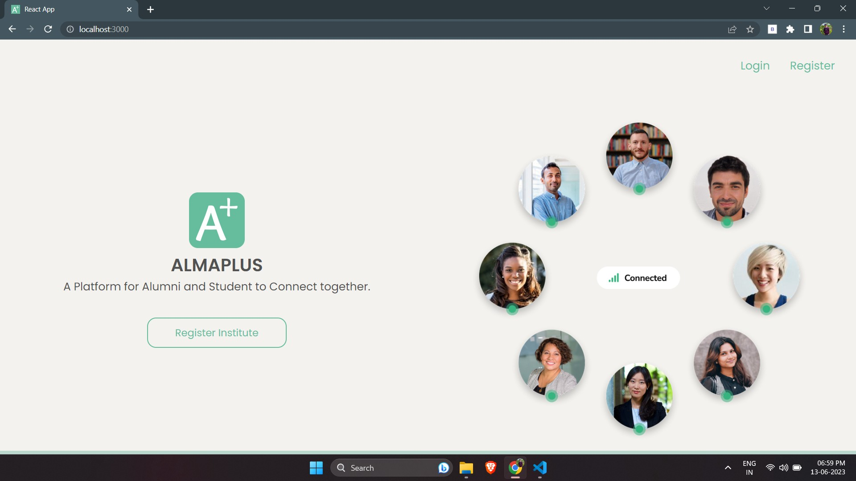

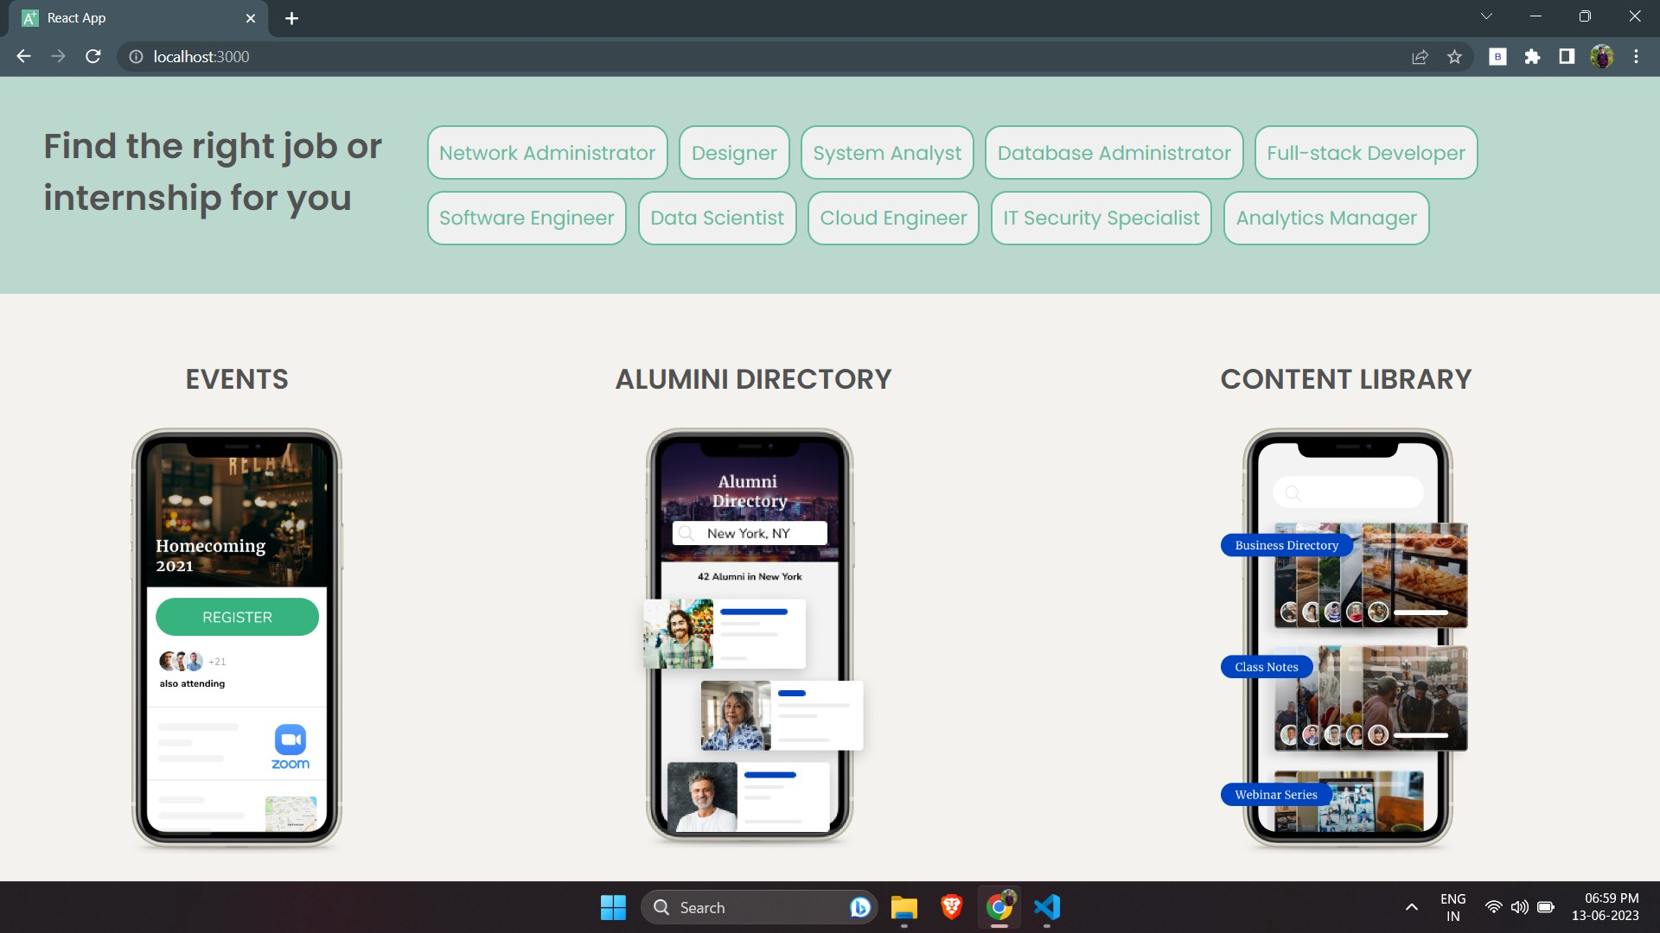

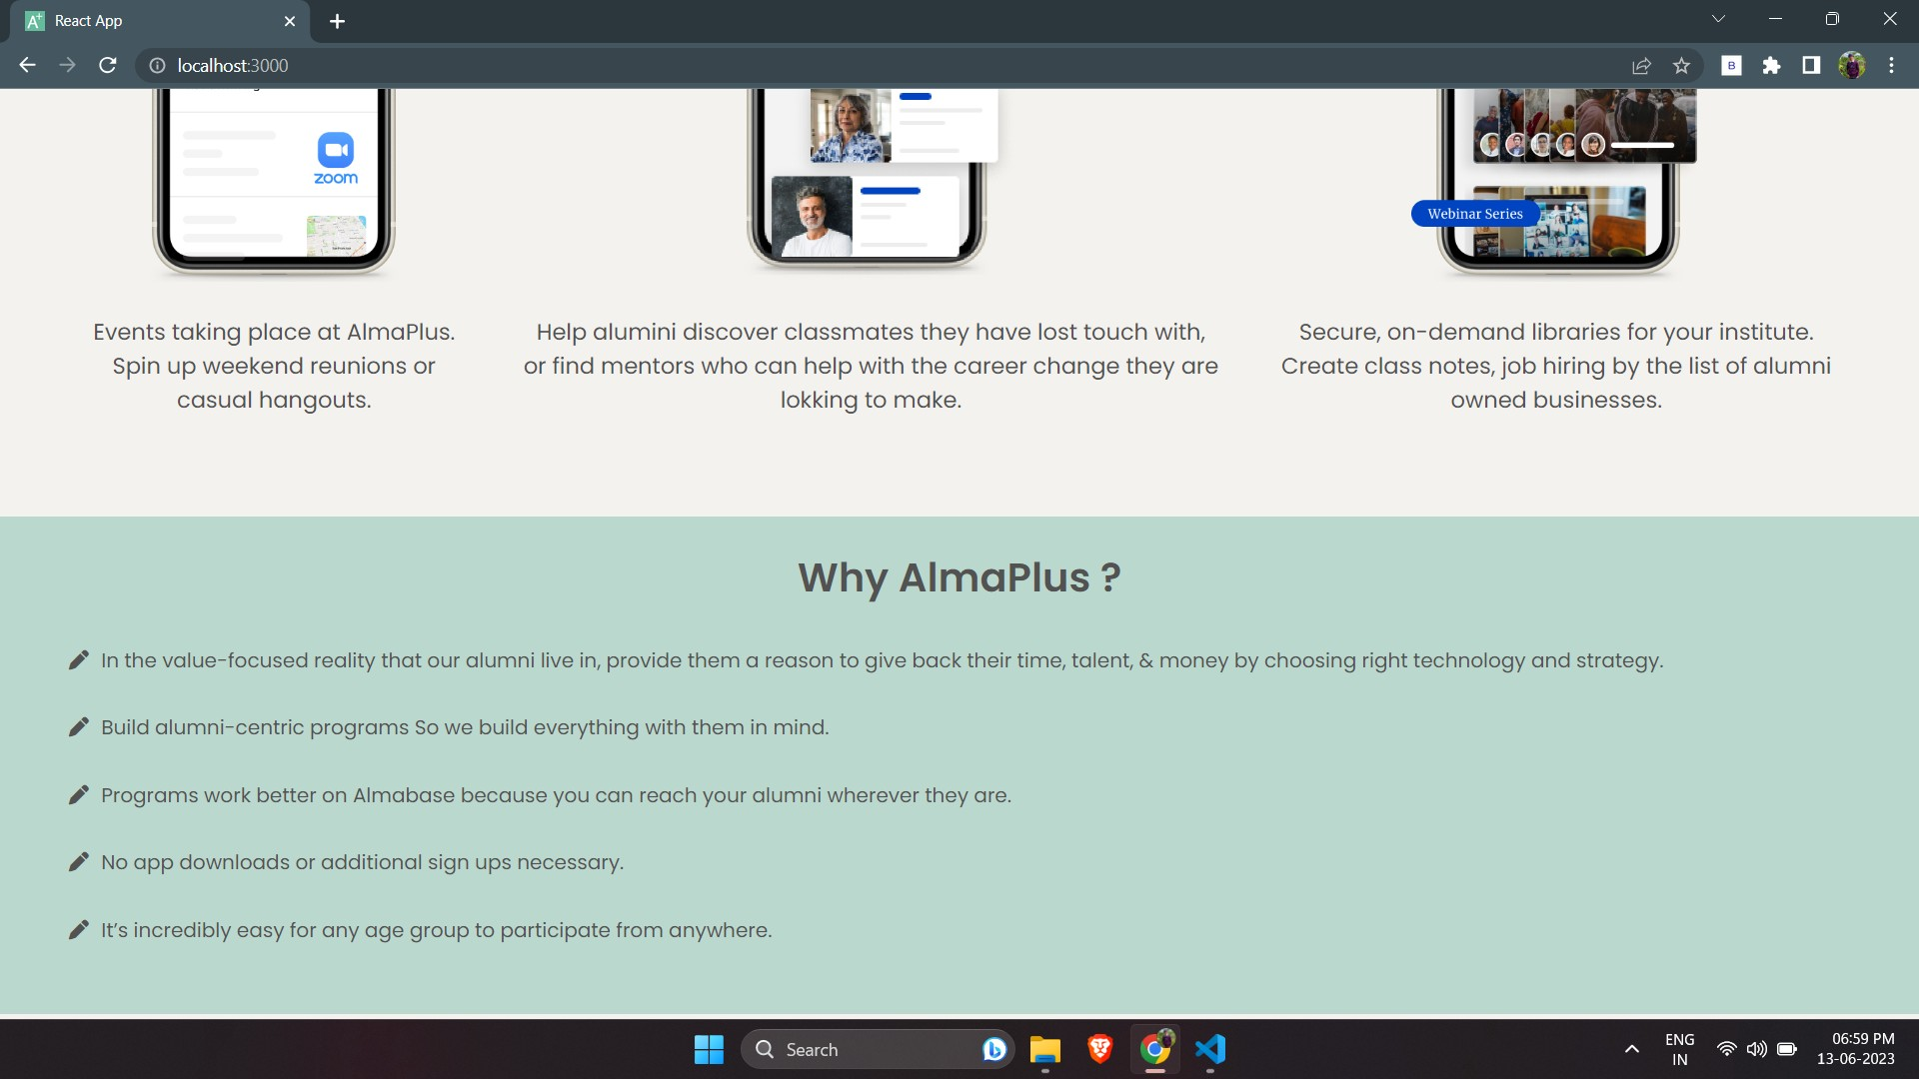

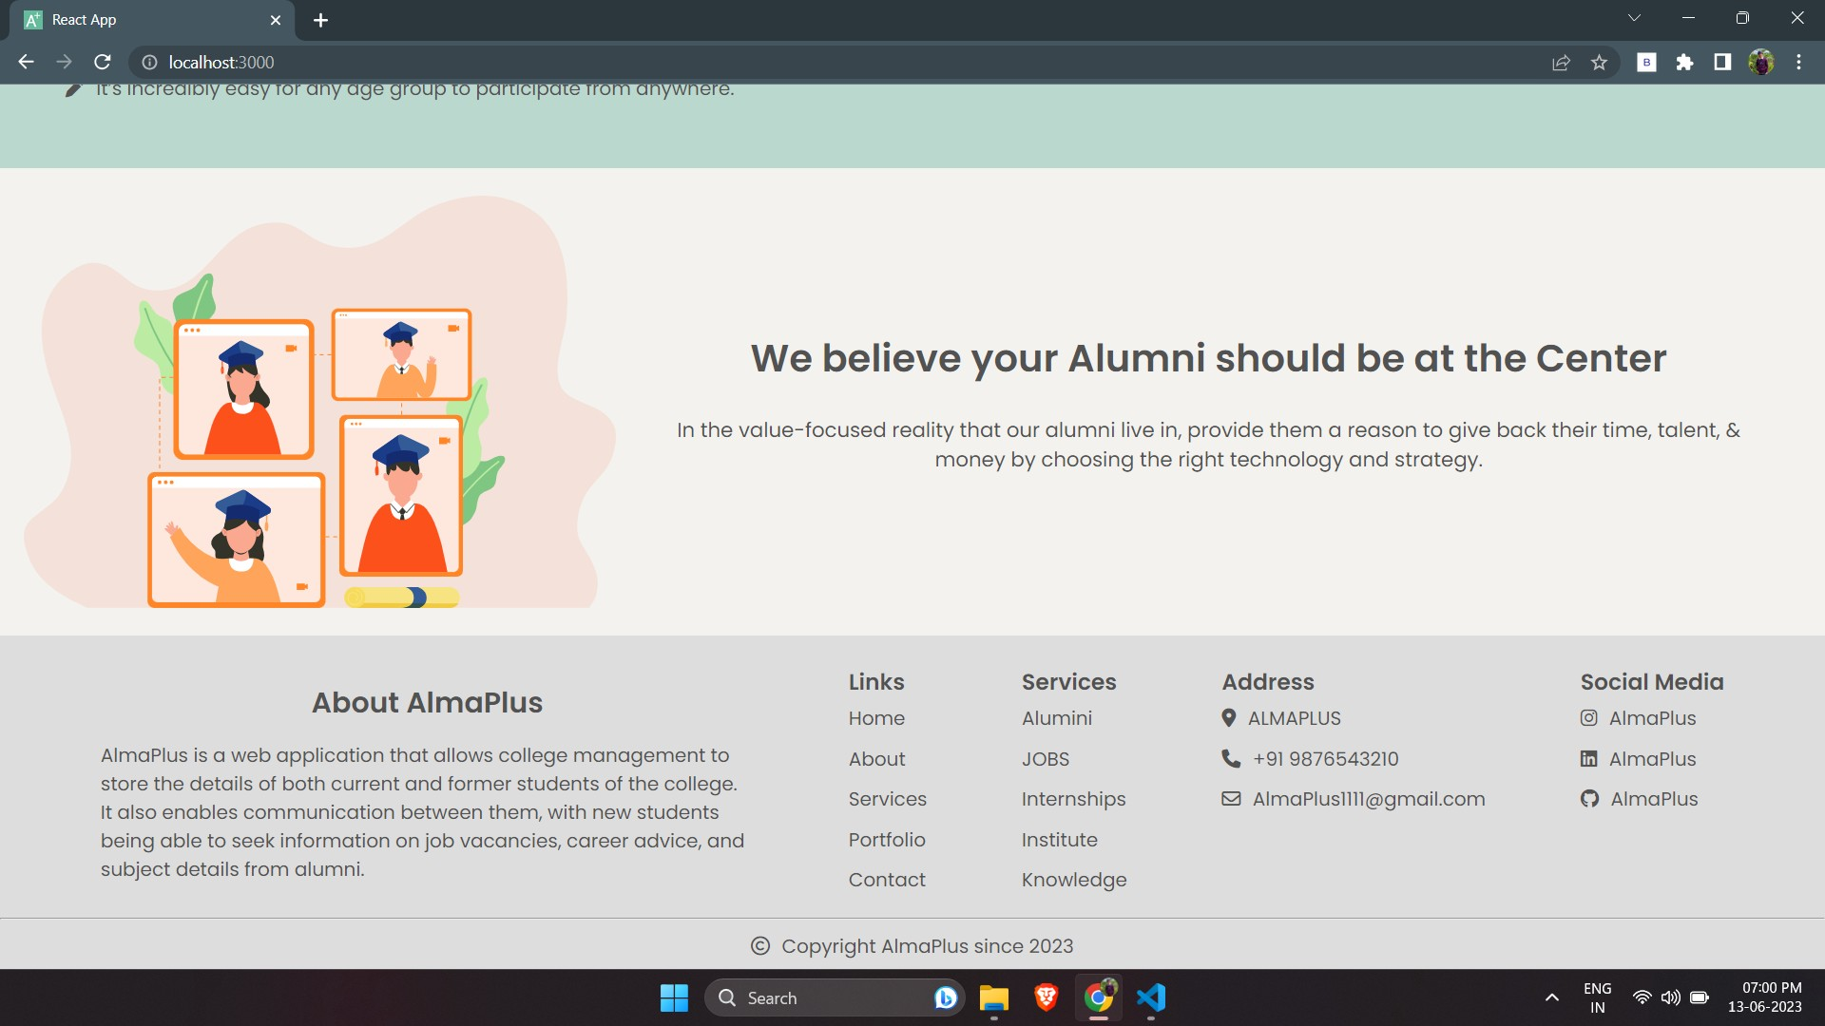

1. **Login Page**

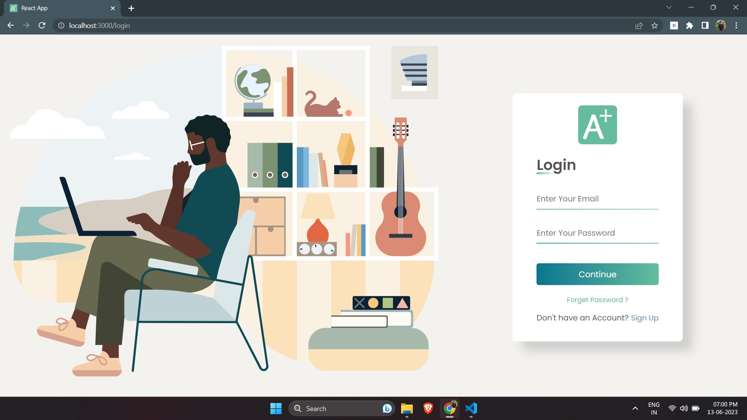

1. **Register Page**

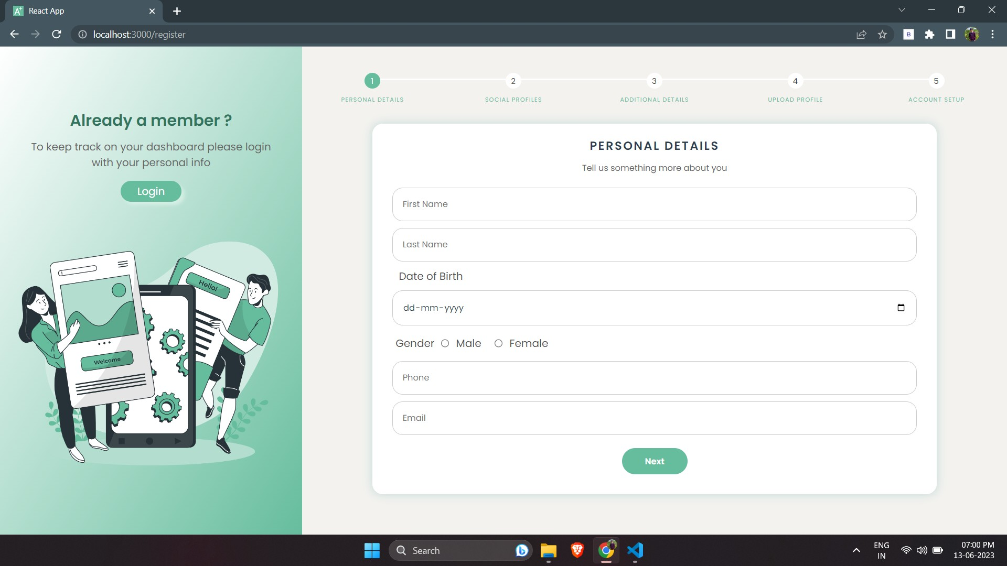

1. **Forgot Password**

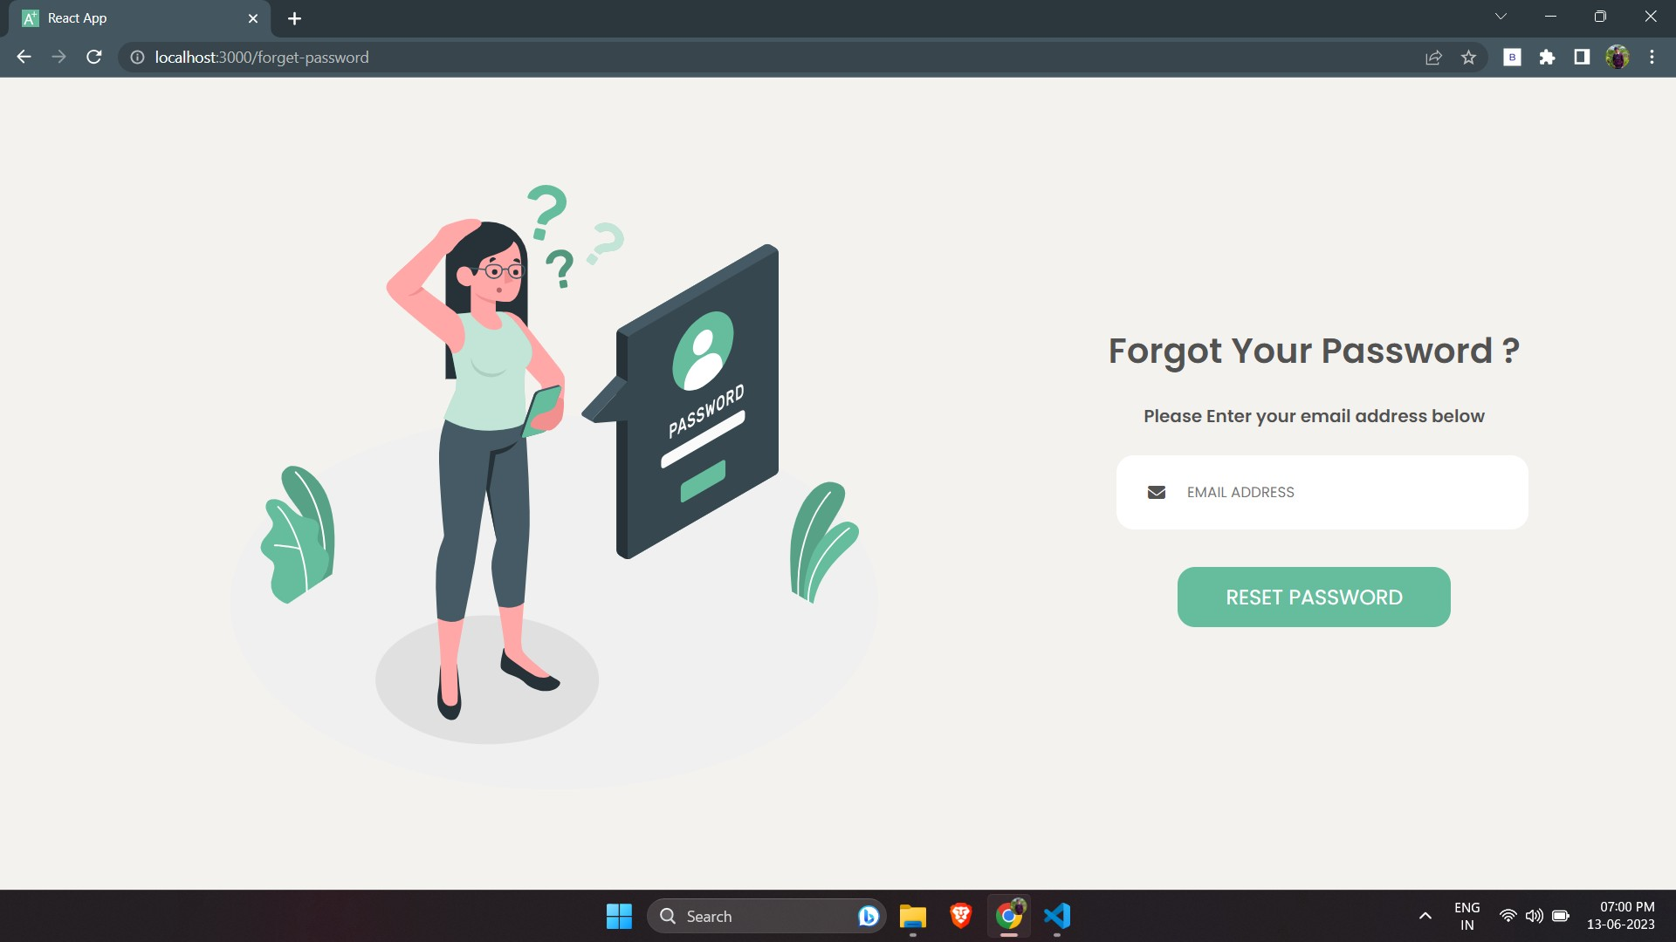

1. **Home Page (After Login)**

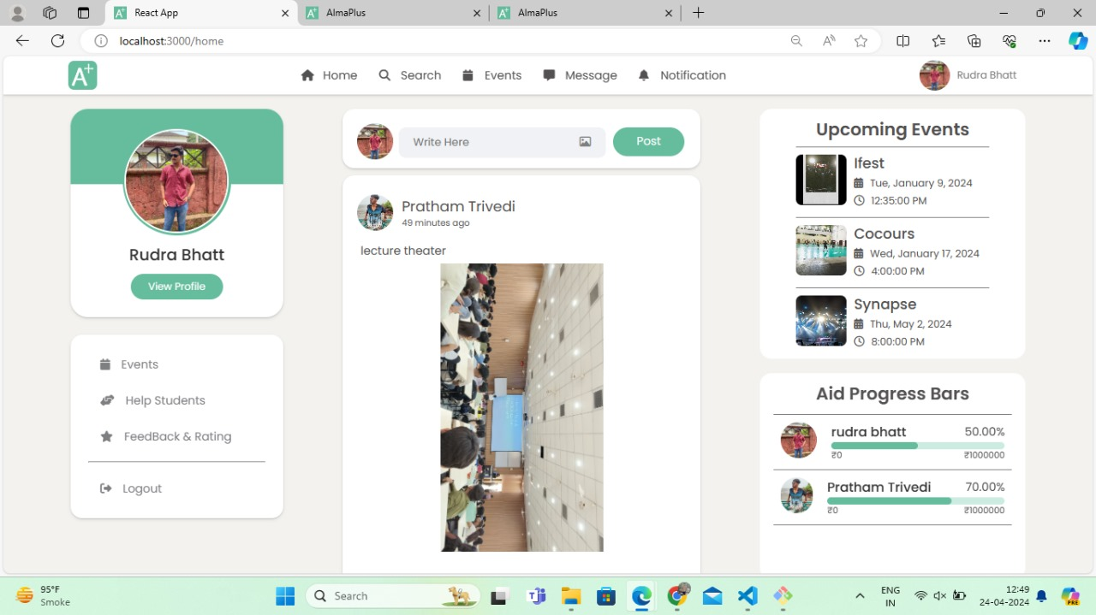

1. **Search Connections**

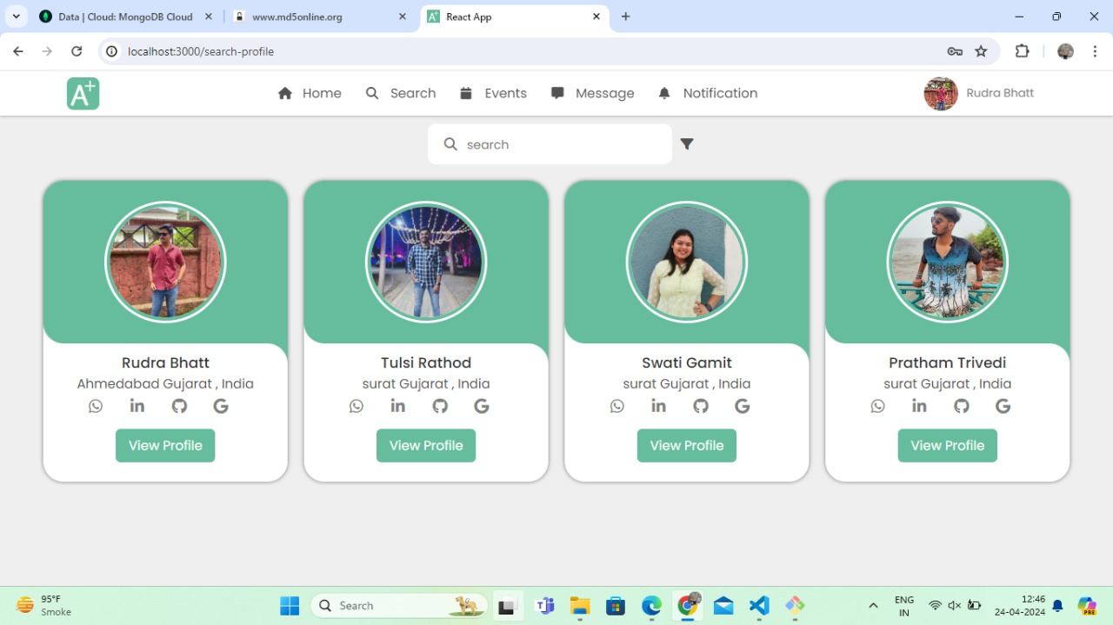

**Search Connections (Filter)**

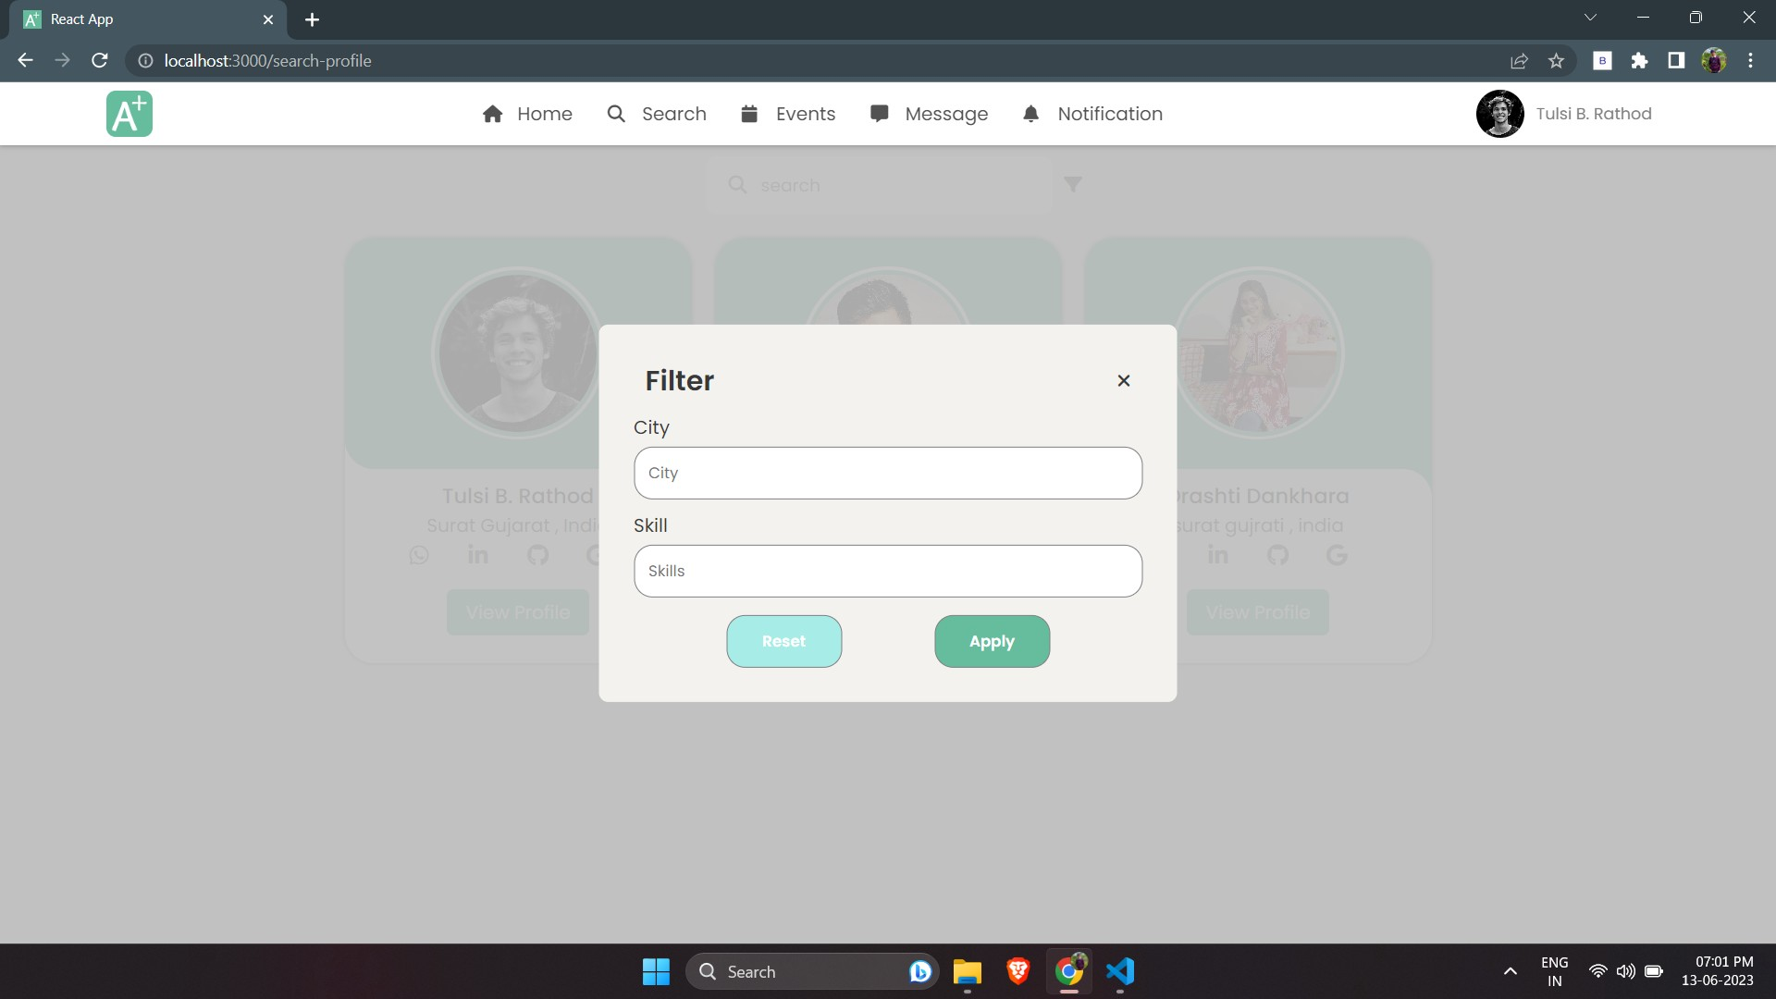

1. **View Proﬁle of Connection**

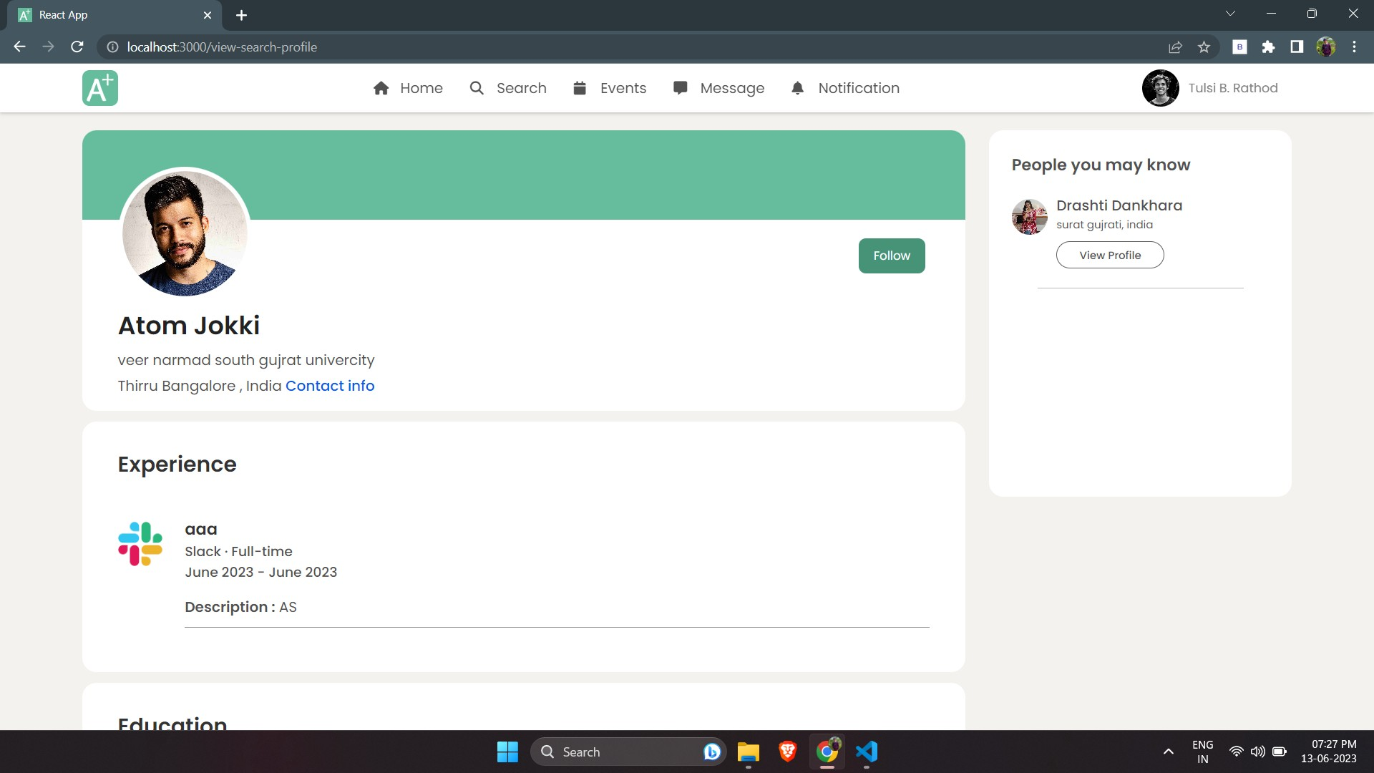

**Follow & Make a Connection**

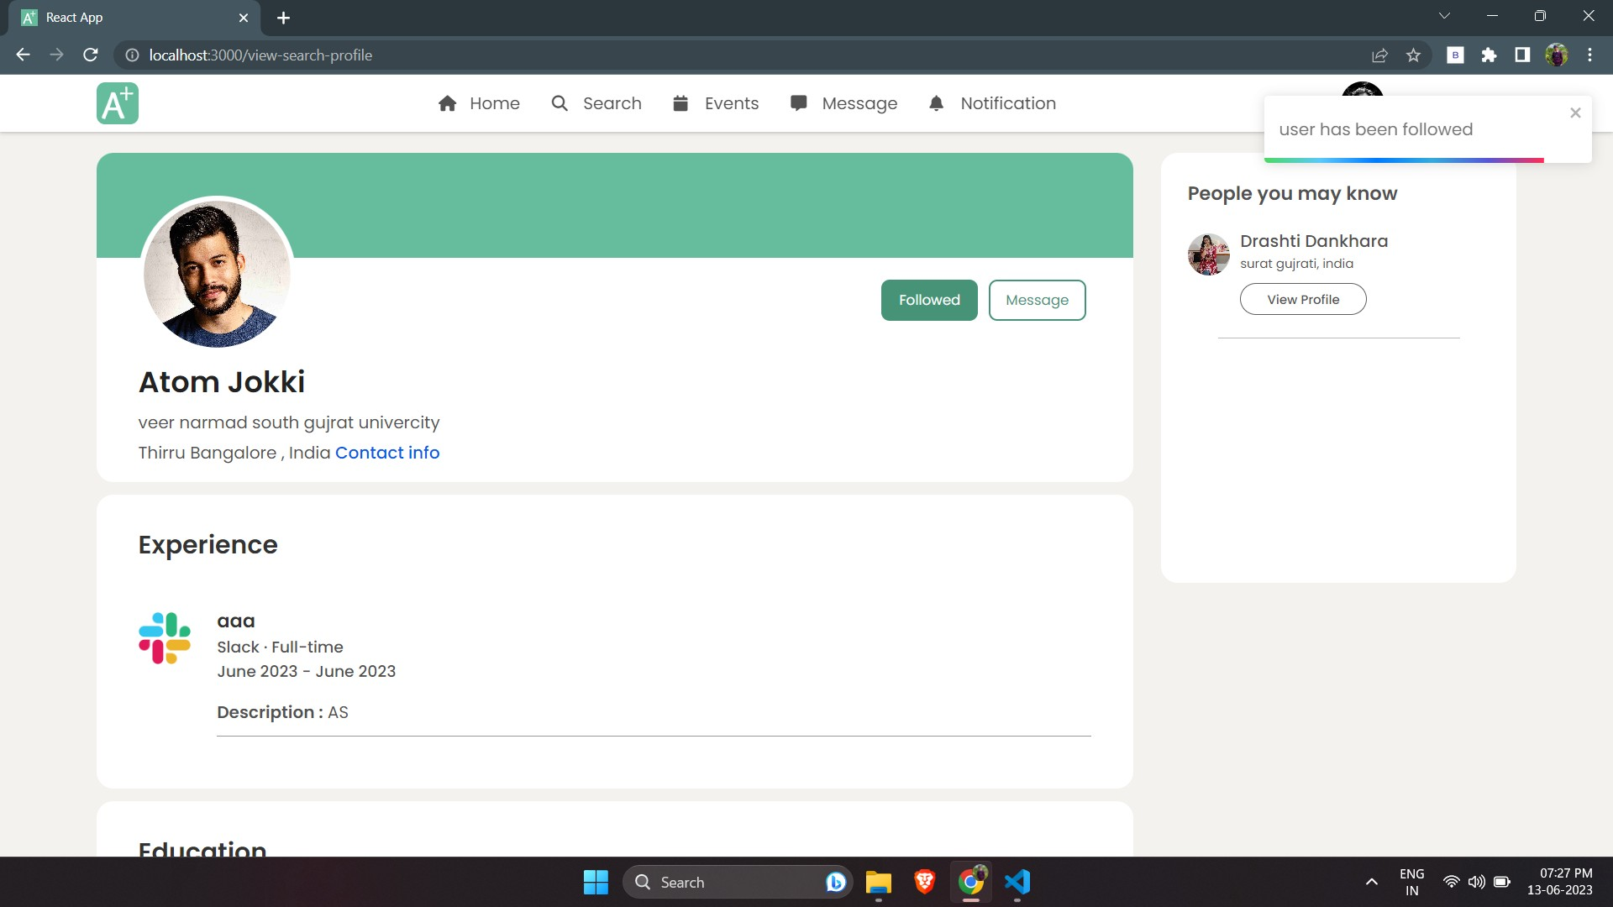

1. **Events**

**Upcoming Events**

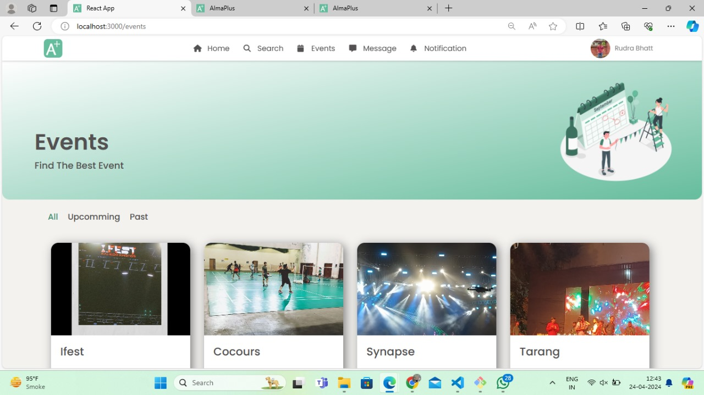

**Past Events**

1. **Students Help Corner**

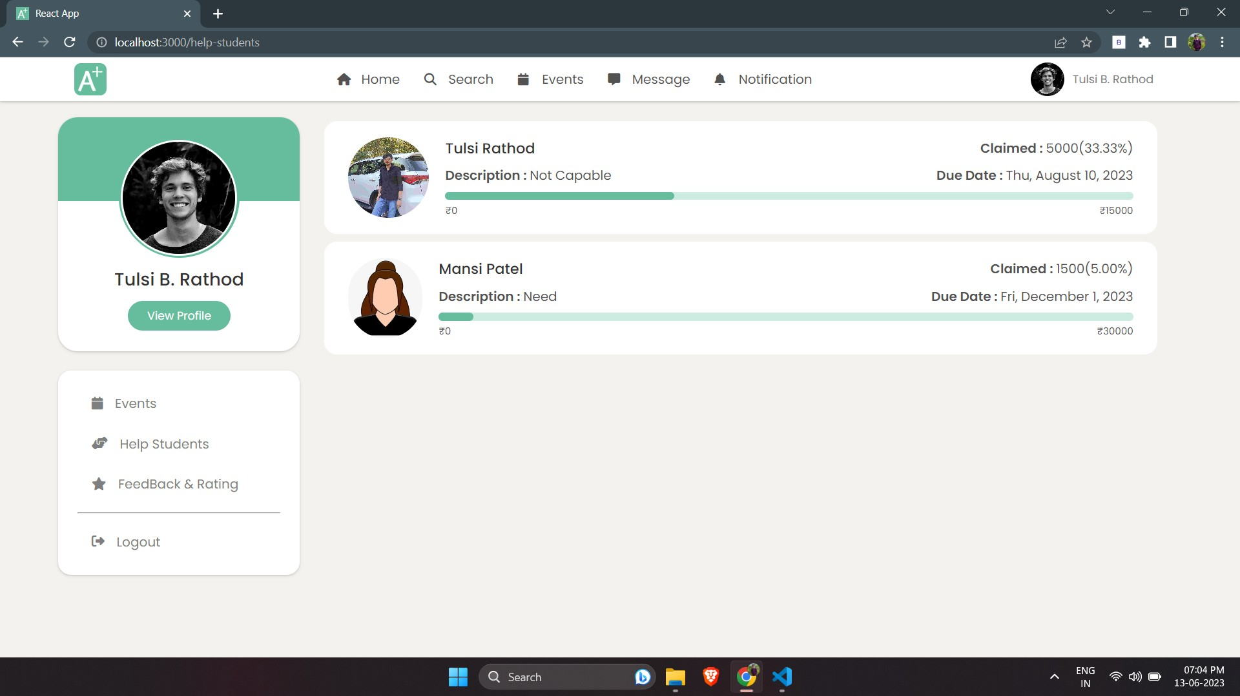

1. **Message Page**

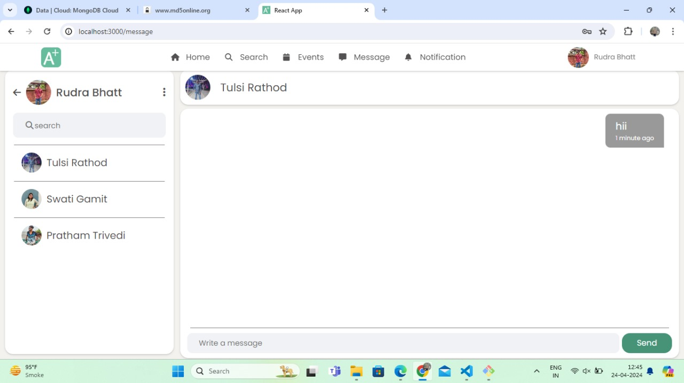

**Open Chat**



1. **Notiﬁcation Page**

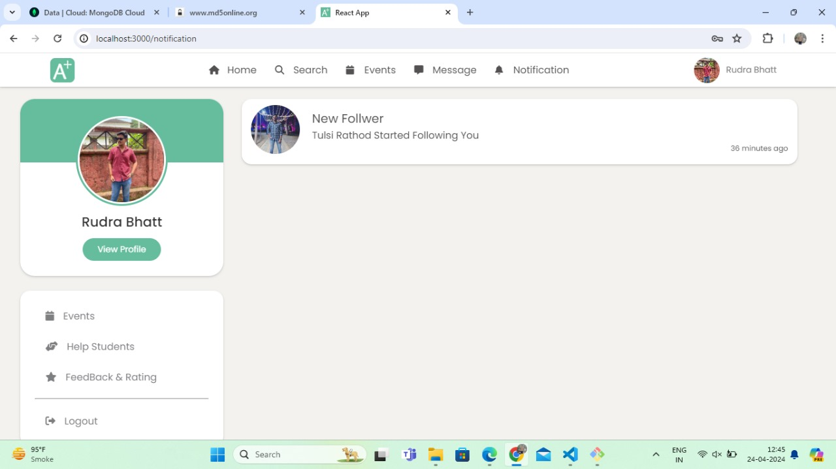

1. **View Proﬁle**

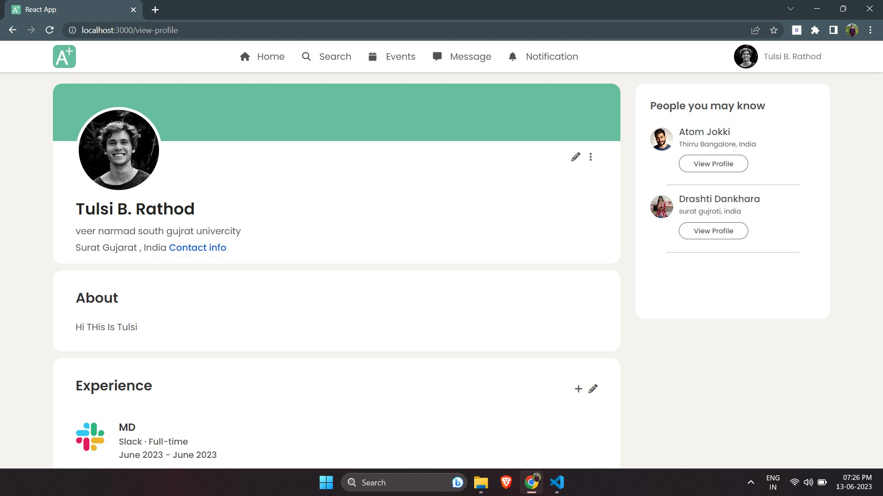

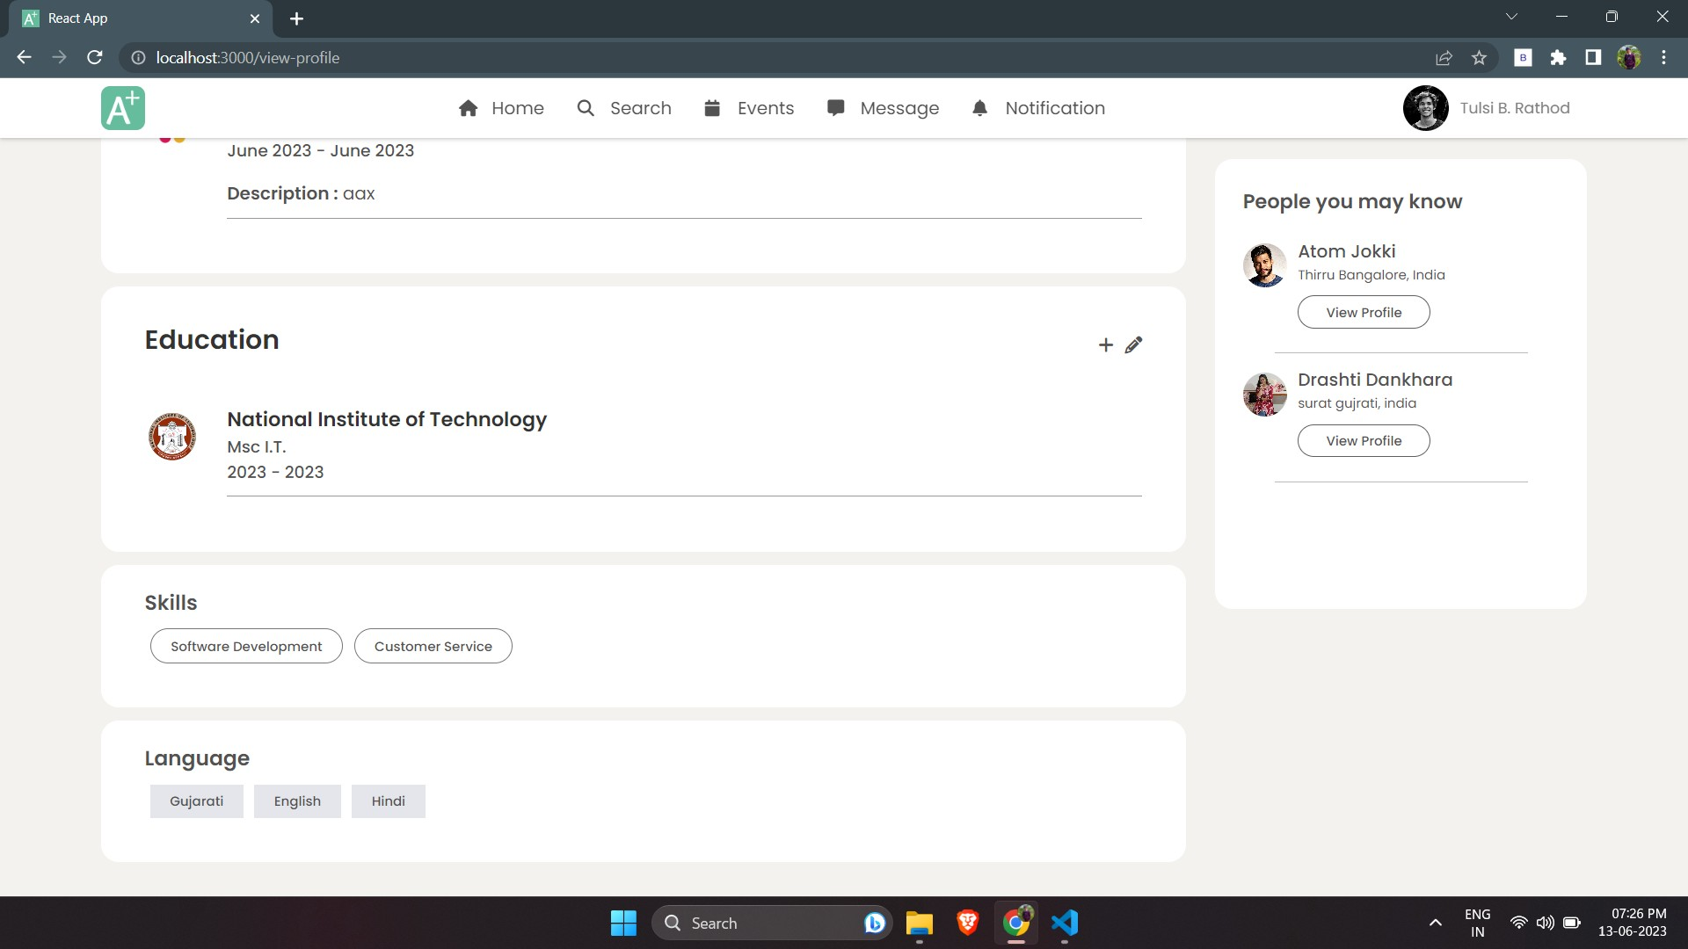

**Edit Proﬁle**

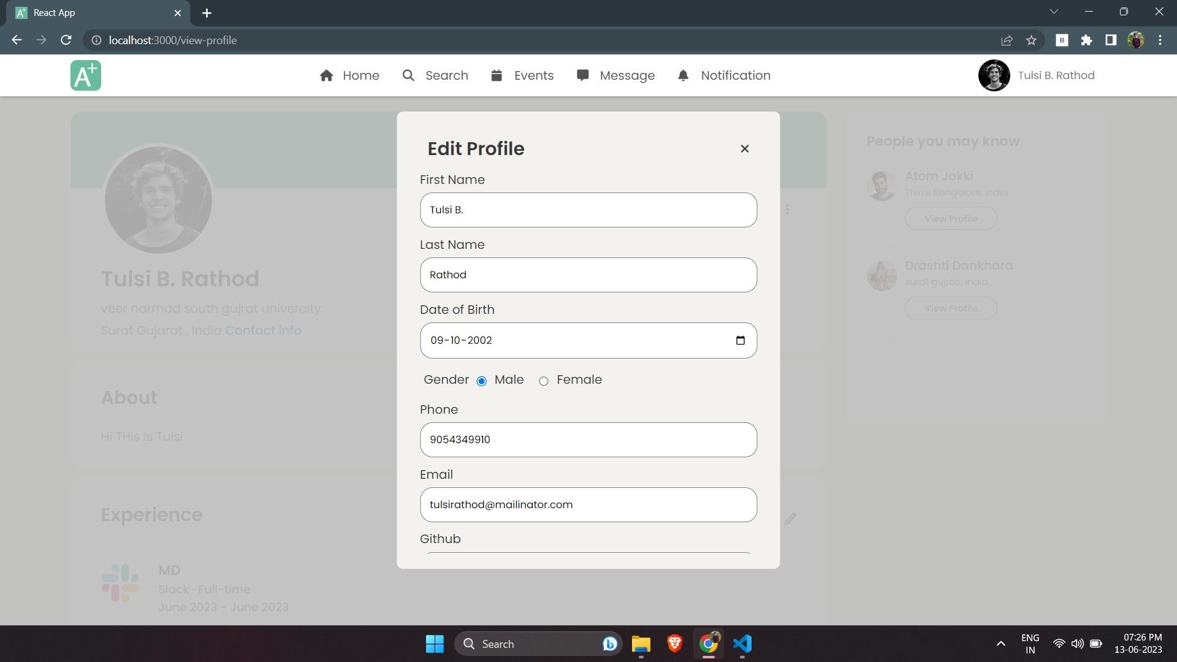

**Handle Followers & Followings**

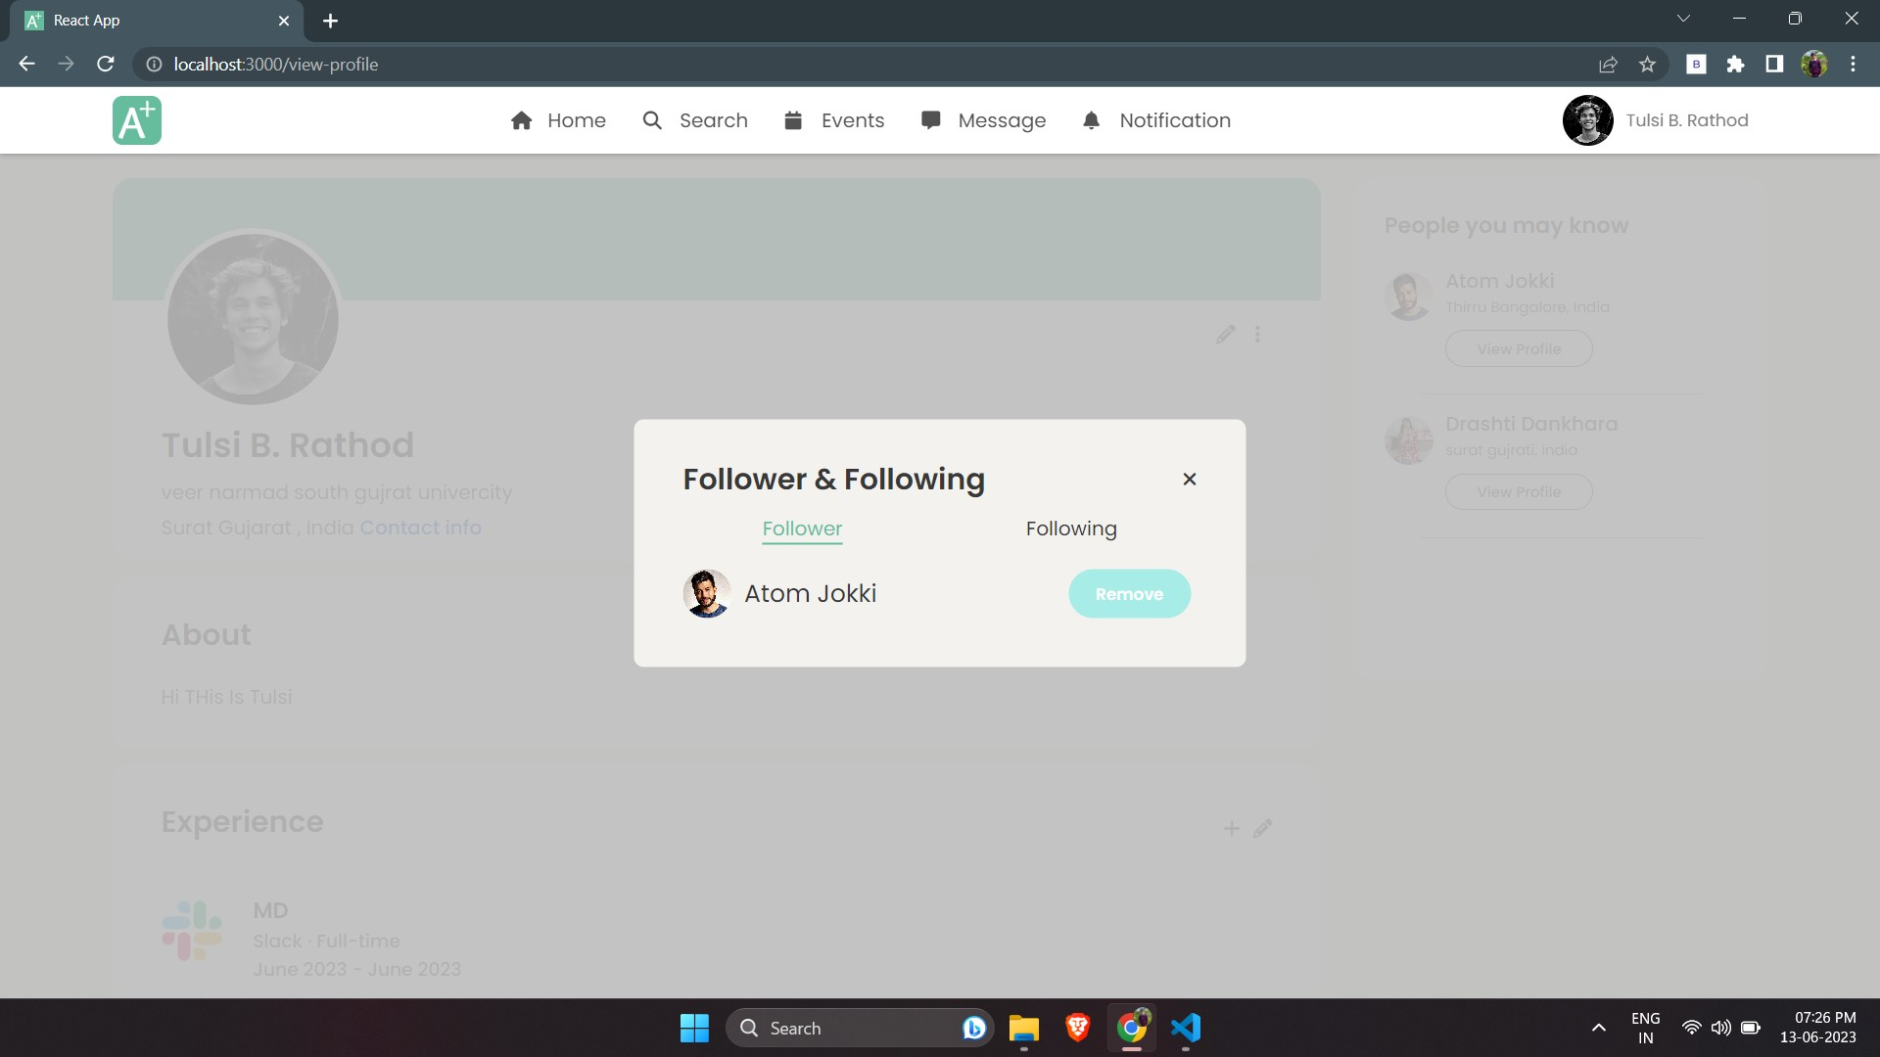

**Change Password**

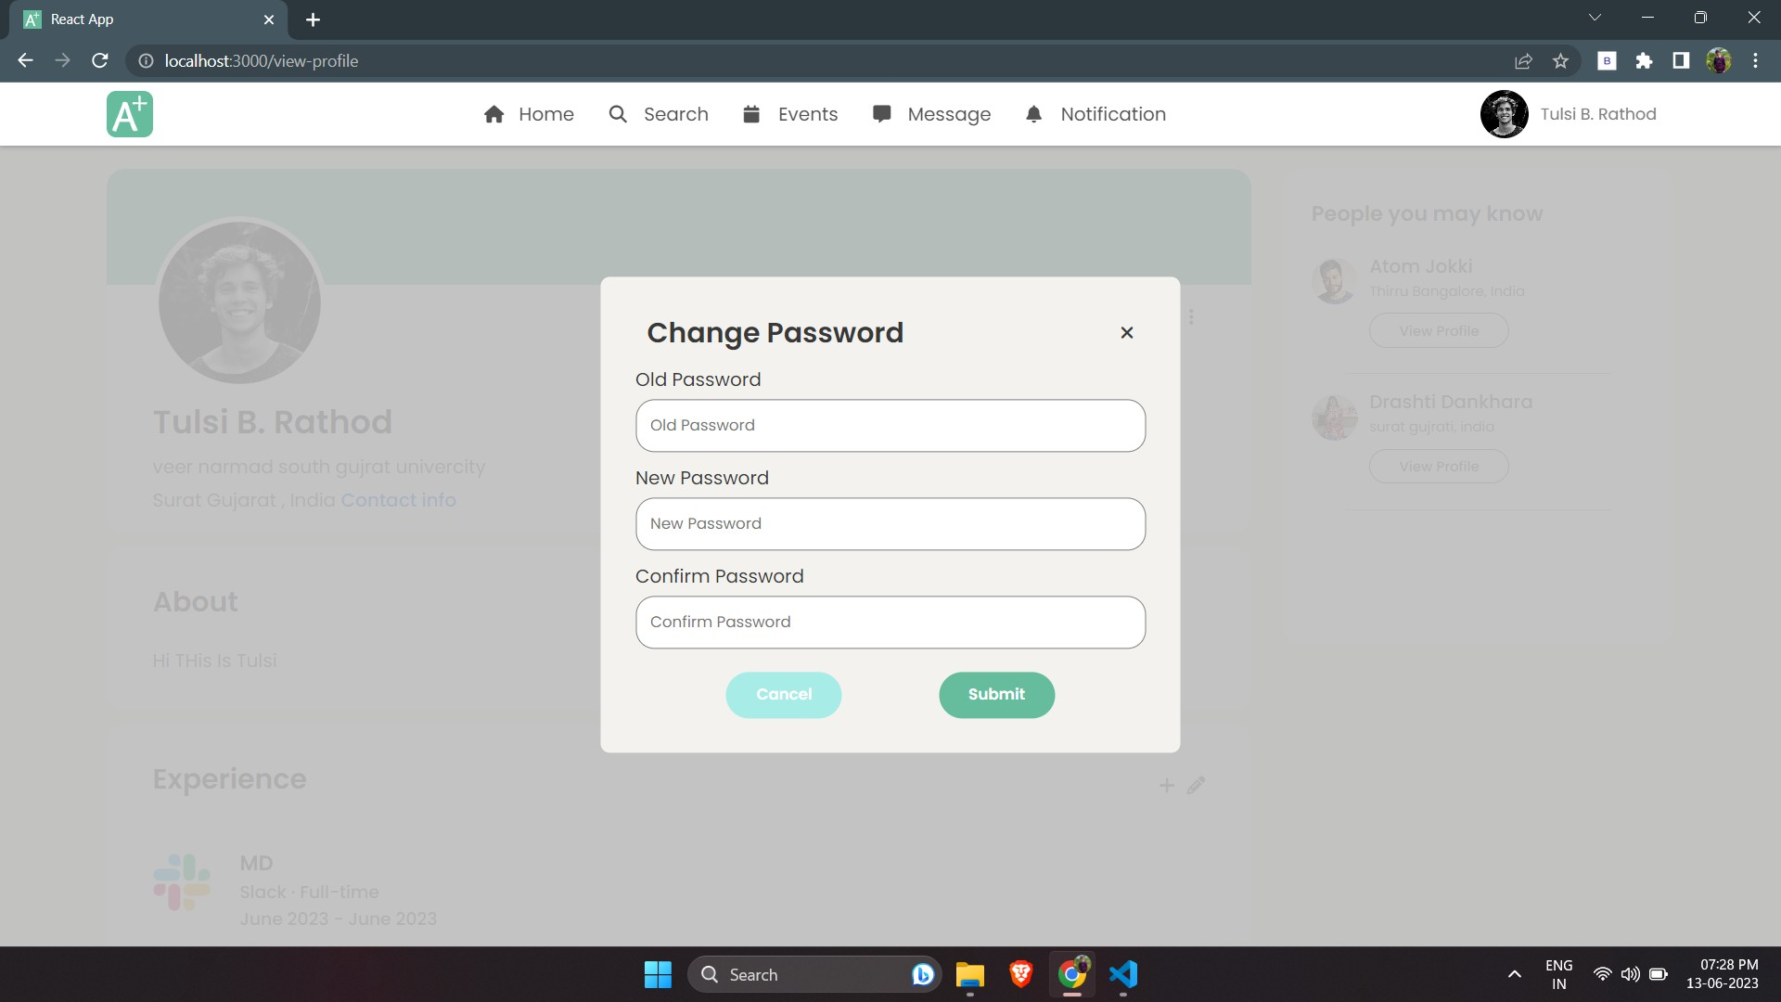

1. **Feedback & Ratings**

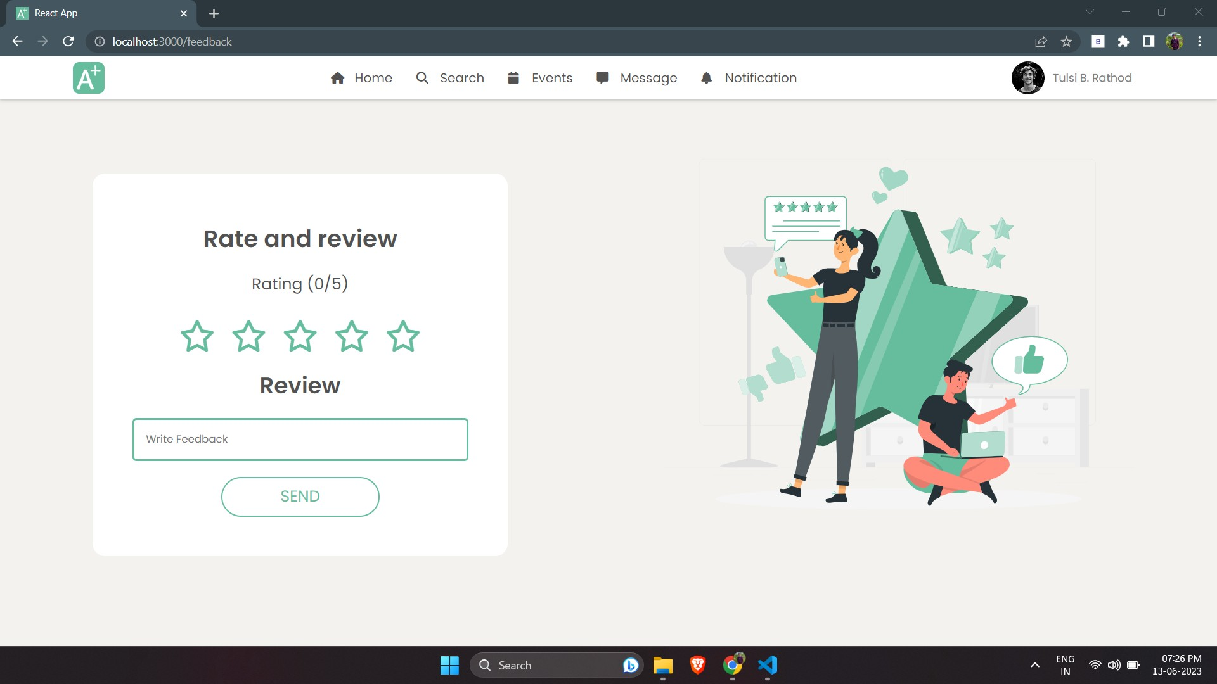

# Institute Panel

1. **Login Page**

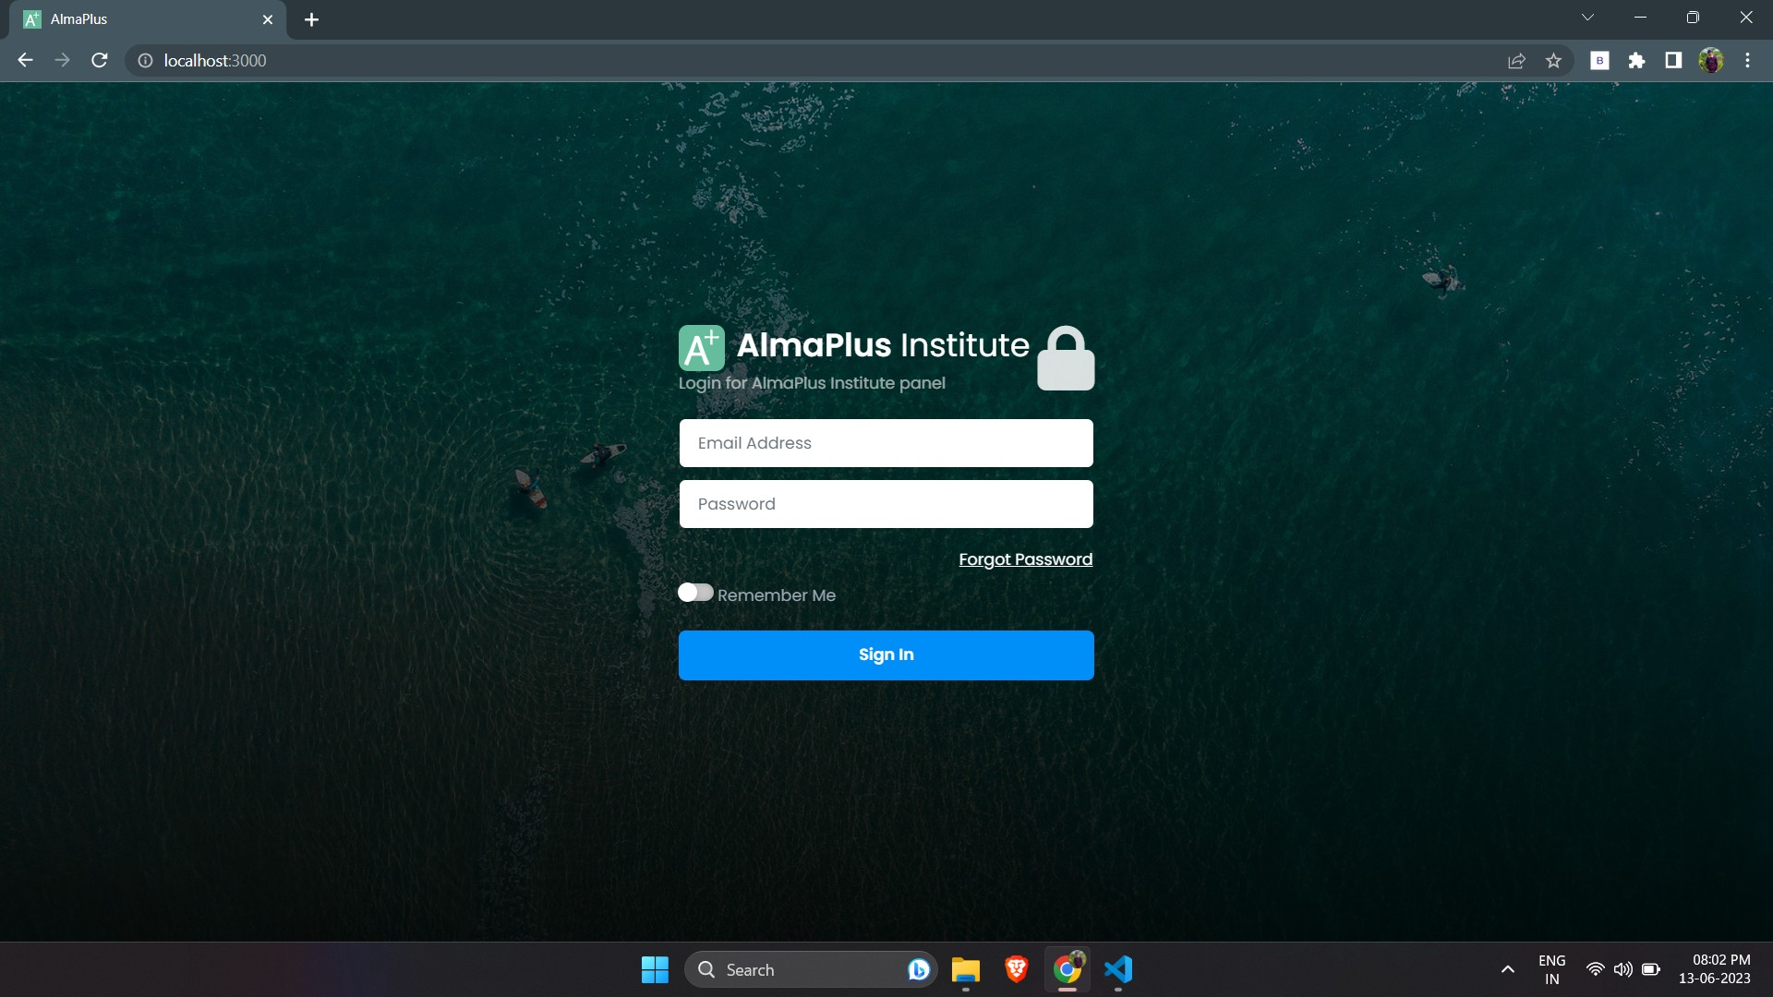

1. **Forgot Password**

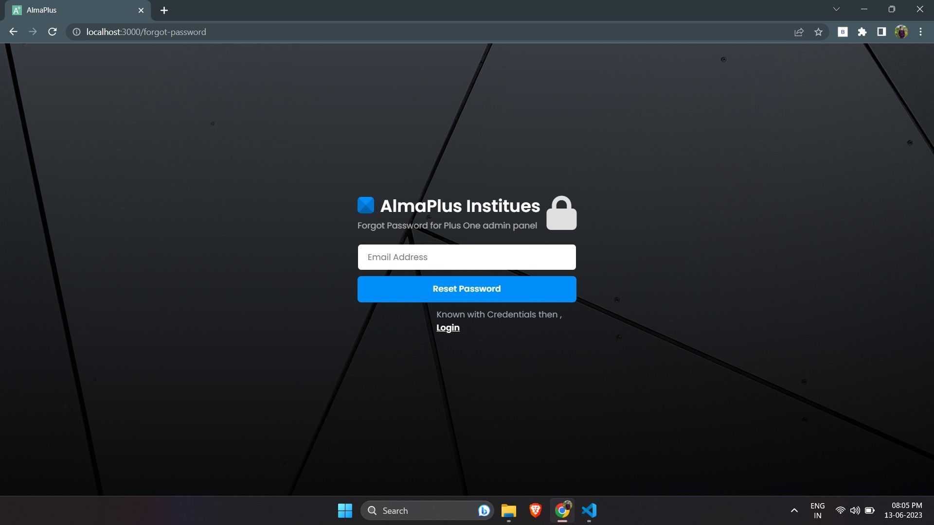

1. **Dashboard**

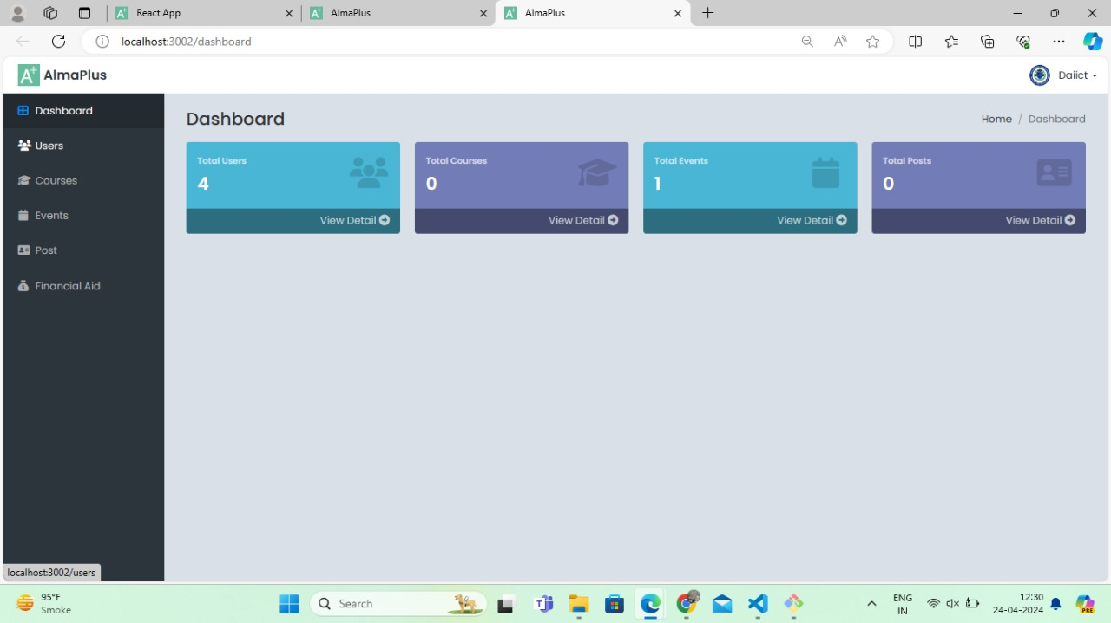

1. **Users**

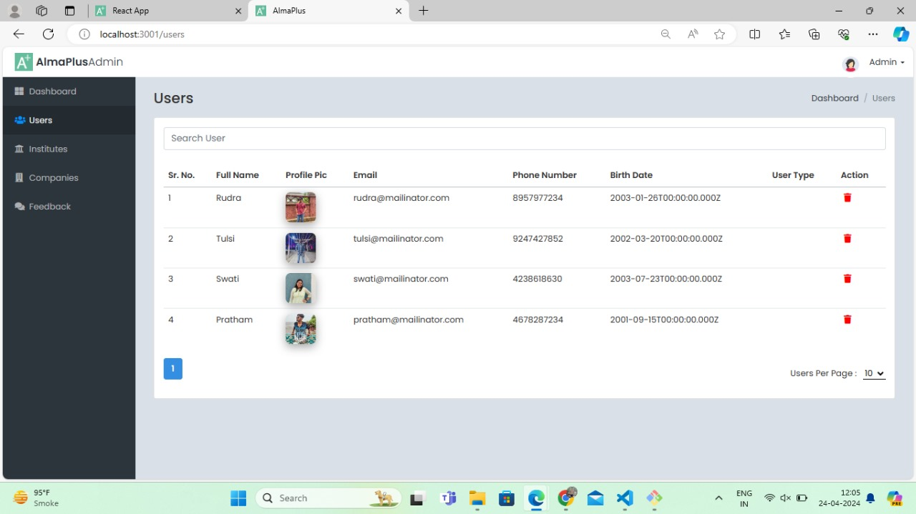

1. **Courses**

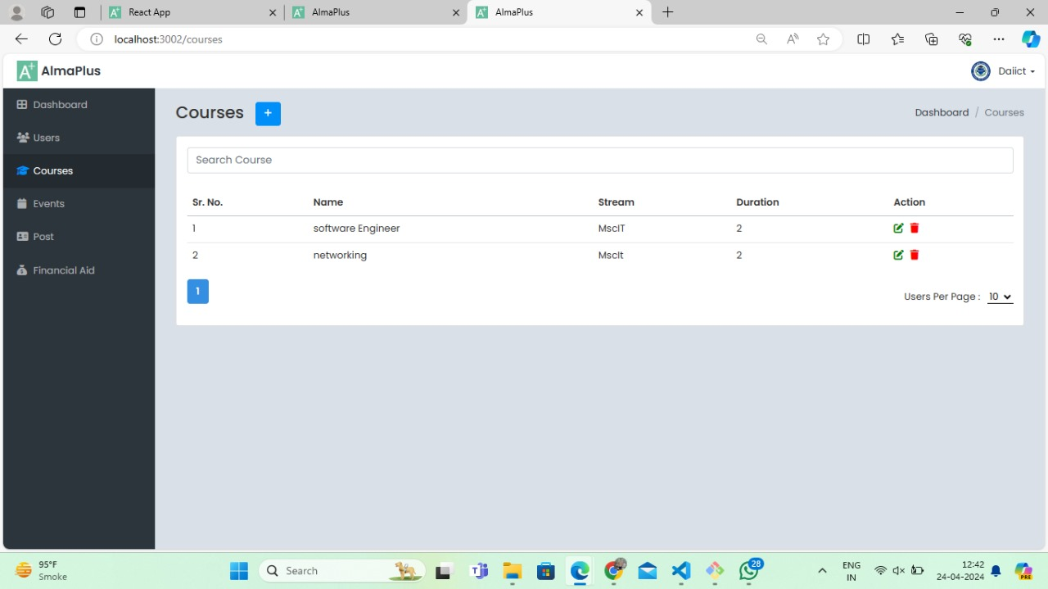

1. **Events**

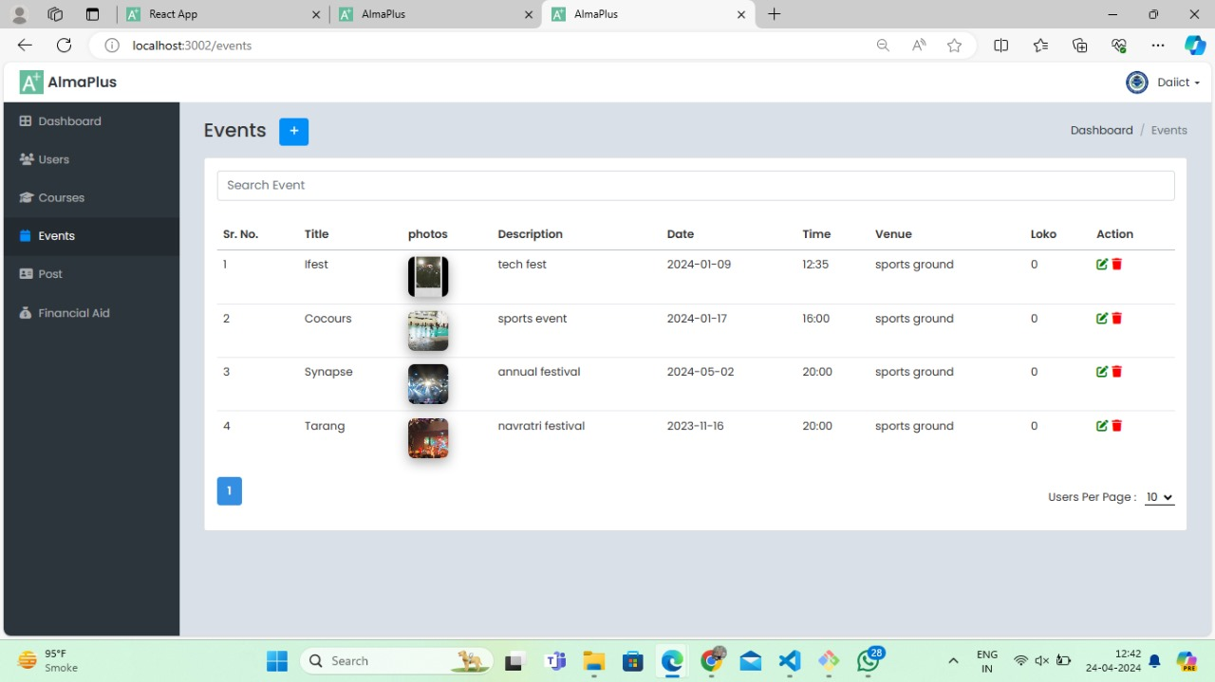

1. **Posts**

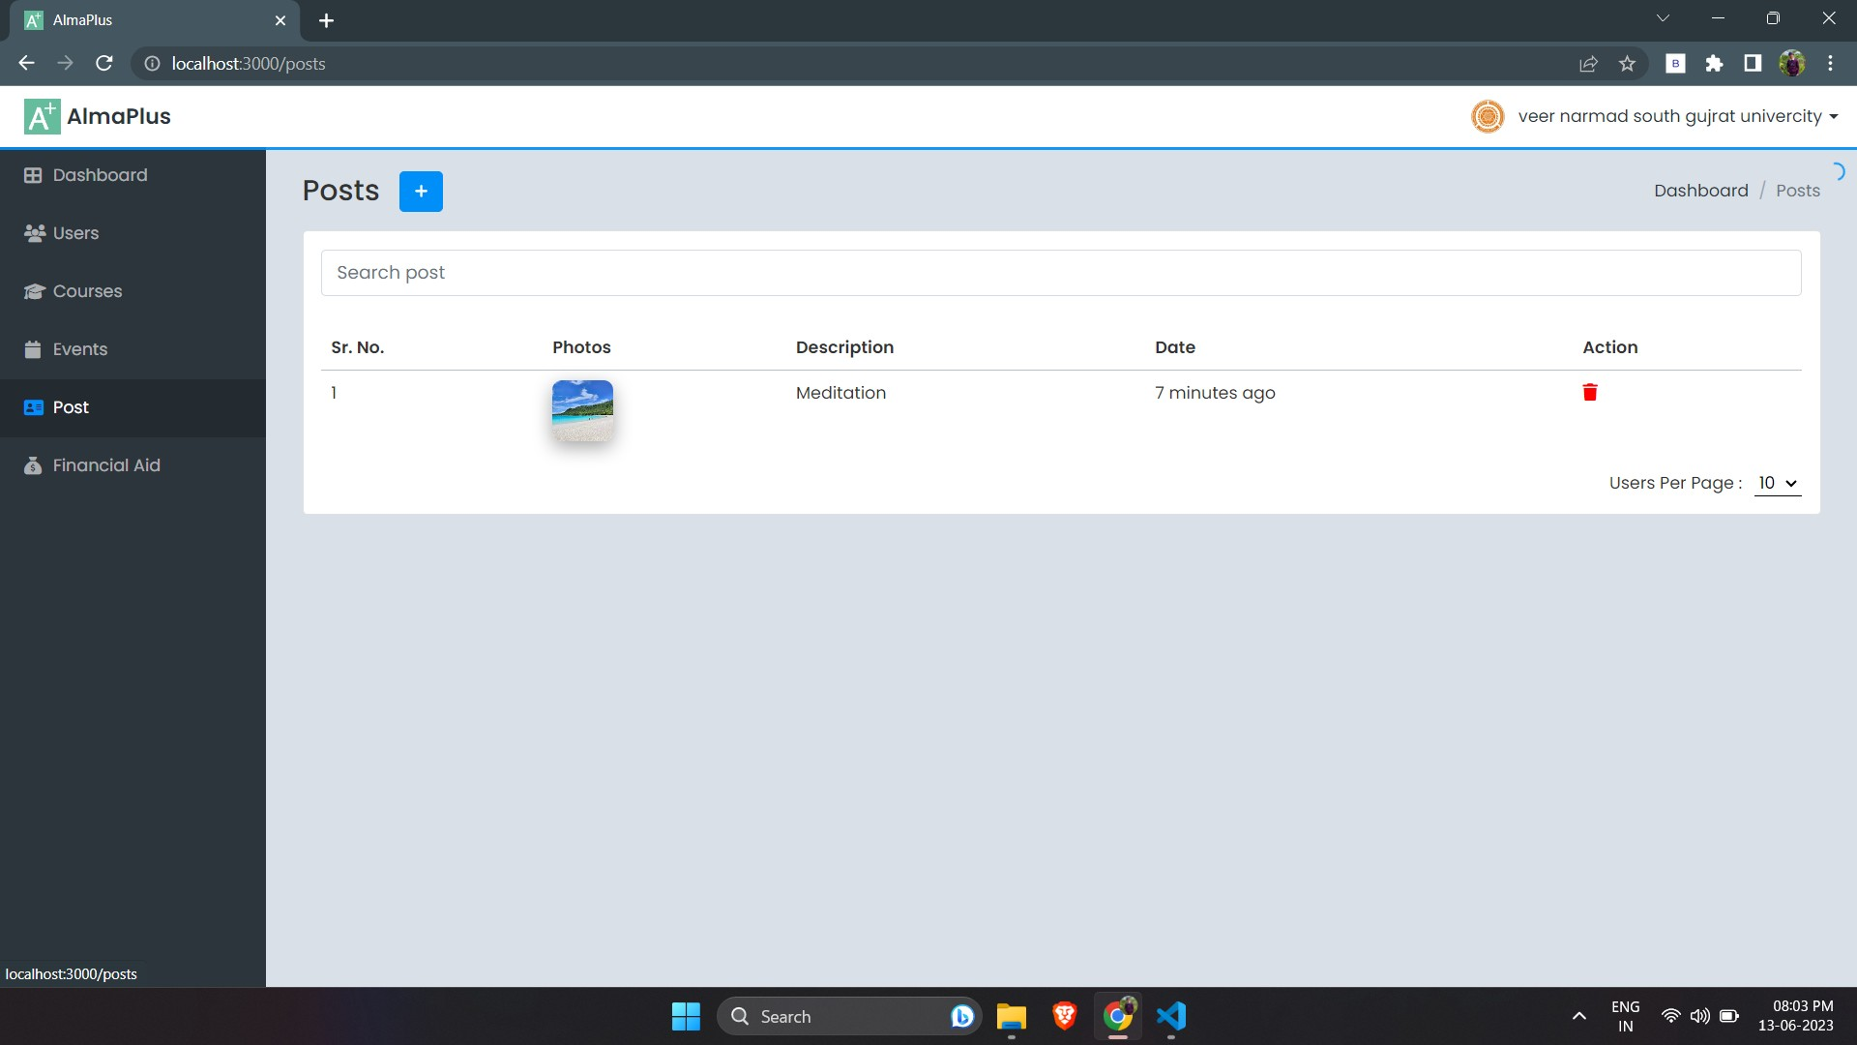

1. **Financial Aid**

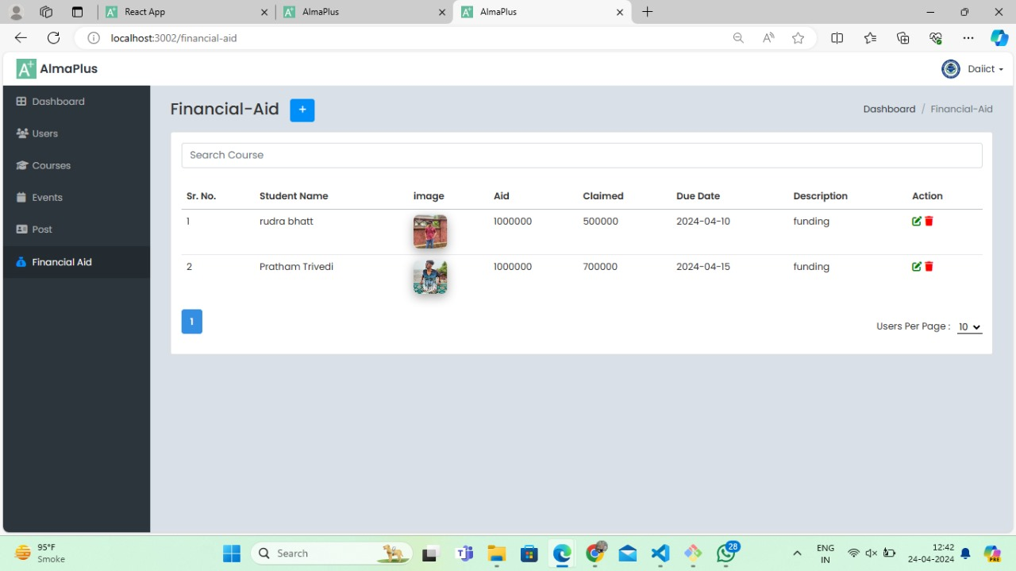

1. **Edit Proﬁle**

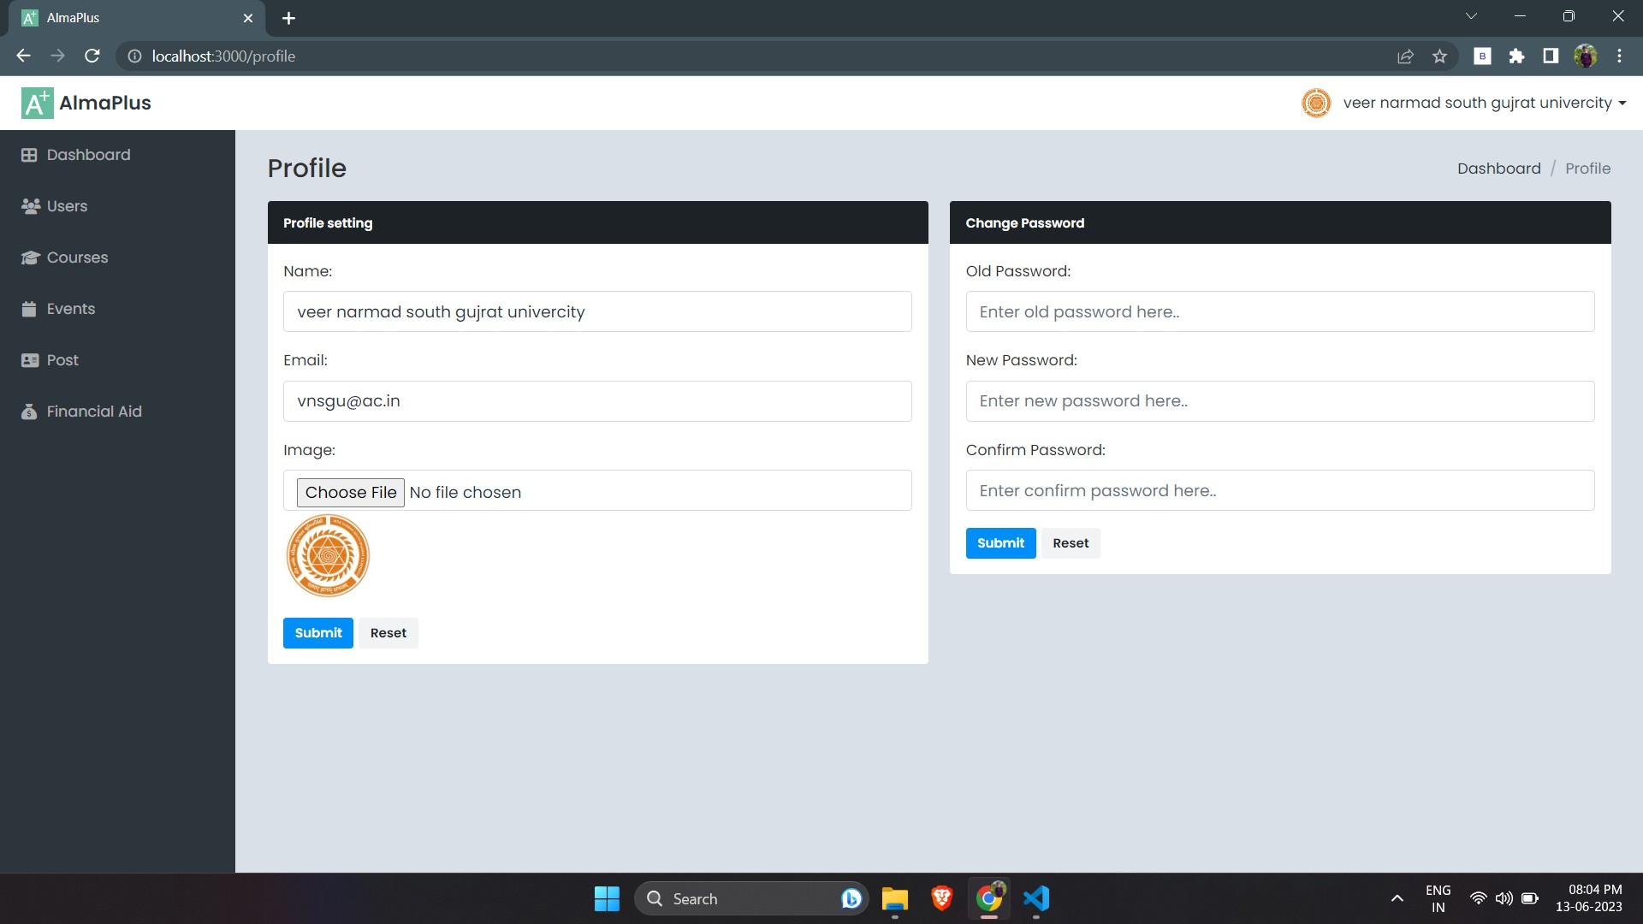

# Admin Panel

**1. Dashboard**

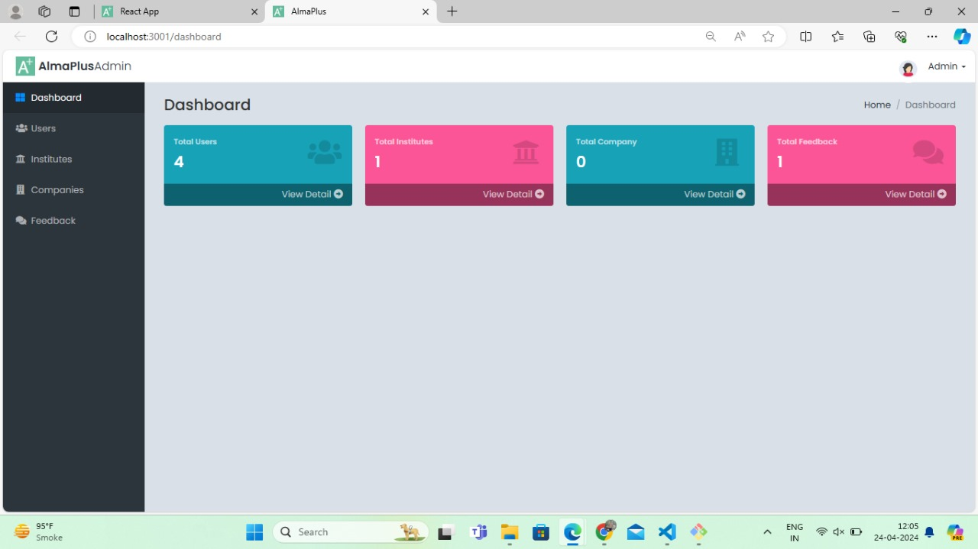

# 7. REFERENCE

GFG : [https://www.geeksforgeeks.org](https://www.geeksforgeeks.org/) Draw.io : <https://app.diagrams.net/>

MongoDB Atlas : <https://www.mongodb.com/> Stack Overﬂow : [https://stackoverﬂow.com/](https://stackoverflow.com/) YouTube : [https://www.youtube.com/](https://stackoverflow.com/)